- Find the distance between the points (4,-1) and (-5,3)
- Find the midpoint of the line segment with endpoints (5,-2) and (-3,12)
- Graph the equation $y=2{\left(x-1\right)}^{2}$
- $Graph the equation 3x-y=-1$
- Find the equation of the line with slope 0 and y-intercept (0,-2). Write your answer in the form y=mx+b
- Write the equation of the line passing through (5,2) and (4,-2)
- Find the vertex of the graph of the parabola f(x)=-$x^{2}+4x-5$
- $Given the function f\left(x\right)={3x}^{2} its range is what?$
- $Evaluate g\left(f\left(1\right)\right)where f\left(x\right)=4x-5 and g\left(x\right)=2x+3$
- $Determine the x-intercept of the graph of x=y^{2}-4$
- $Determine the center of the circle {\left(x+2\right)}^{2}+{\left(y-1\right)}^{2}=16$
- $Given f\left(x\right)=x^{2}-4 if x<-1$
3x+2if x$≥1$ find f(-1)

- Which set of ordered pairs (x,y) define y as a function of x?
- $\left\{\left(4,7\right), \left(3,7\right), \left(2,5\right), \left(8,-8\right)\right\}$
- {(5,1), (-3,4), (-3,2)}

- Determine the domain of the function f(x) = $\sqrt{6-x}$
- Consider all the ordered pairs shown on Graph A and all the ordered pairs shown on Graph B. Which set of ordered pairs defines a function?
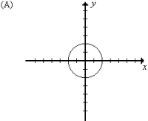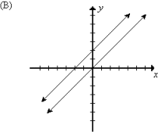

- The length of the base of a triangle is eight times the length of its altitude. Express the area (A) of the triangle as a function of its altitude x.
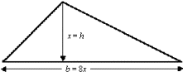
- Find the slope of the line passing through the points (-1,-2) and (1,4)

For any two parallel lines:
A. | the slopes are zero
B. | the slopes are reciprocals
C. | the slopes are positive
D. | the slopes are equal

- Find the value of x in the domain of f(x)=-2x-3 for which f(x)=3
- If the quadratic function f(x)=${2x}^{2}$-4x+6 is graphed the range has
- a maximum value
B. | a minimum value
C. | no maximum or minimum value
D. | many maximum and minimum values

