1.)

2.)
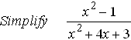

3.) Perform the indicated operation
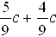

4.) Write 9.37 x in decimal form

5.) Find the absolute value of -11

