4. Determine if x(n) = cos(pi*n/4)cos(pi*n/4) is periodic. If periodic, calculate period.
Not periodic
Periodic, π/3
Periodic, 2π/3
Periodic, π/4

5. Determine if x(n) = cos(3t + pi/4) is periodic. If periodic, calculate period.
Not periodic
Periodic, π/2
Periodic, 8
Periodic, π/8

6. For the RC circuit shown in the figure, find the input/output differential equation.
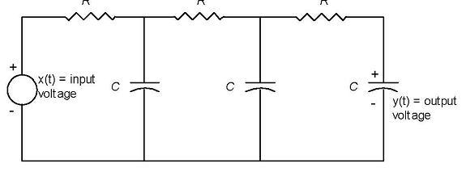
d³y(t)/dt³ + 2R²C² d²y(t)/dt² + 3RC dy(t)/dt + y(t) = x(t)
R³C³d³y(t)/dt³ + 5R²C² d²y(t)/dt² + 6RC dy(t)/dt + y(t) = x(t)
RCd³y(t)/dt³ + 6R²C² d²y(t)/dt² + 5RC dy(t)/dt + 2y(t) = x(t)
R³C³d³y(t)/dt³ + 5 d²y(t)/dt² + RC dy(t)/dt + y(t) = 3x(t)

