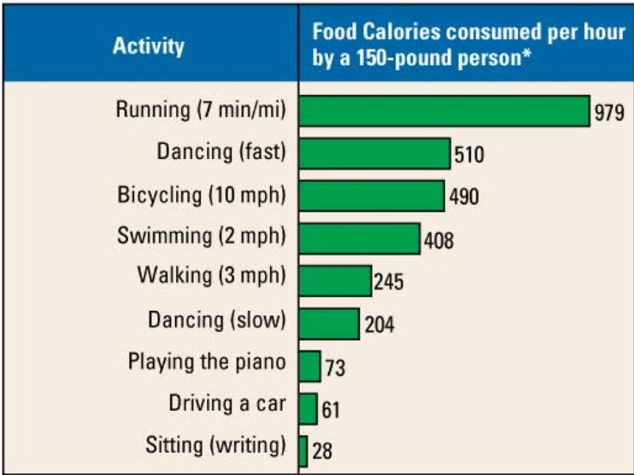
Gaining and losing weight are matters of caloric accounting: Calories in the food you eat minus Calories that you spend in activity. One pound of human body fat contains approximately 3,500 Calories. Using Figure 5.4, compare various ways you could burn off that many Calories. How far would you have to run, swim, or walk to burn the equivalent of 1 pound of fat? For how much time would you have to do each activity? Which method of burning Calories appeals the most to you? The least?

