12. The following balance sheet information was provided by Oleg Company:
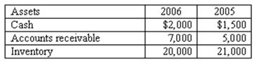
Assuming net credit sales totaled $120,000, what was the company's average days to collect receivables?
18.3 days
21.5 days
60 days
52.1 days

14. The following partial balance sheet is provided for Templeton Company:
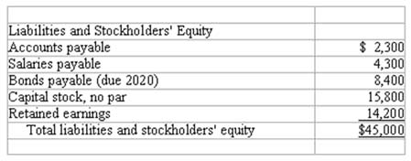
What is the company's debt to assets ratio? (Points: 2)
33%
50%
67%
41%

15. The Walter Wilson Company reported the following income for 2007:
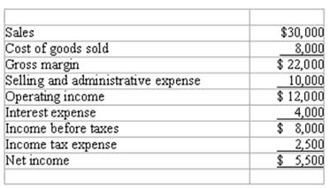
What is the company's net margin? (Points: 2)
73%
40%
27%
18%

17. The Aloysius Company provided the following information from its financial records:
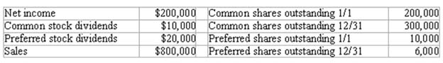
What is the amount of the company's earnings per share? (Points: 2)
$0.72
$0.76
$0.80
$25.00

19. The Ulysses Company reported the following income for 2007:
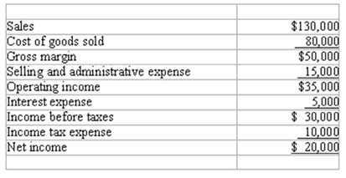
What is the company's number of times interest is earned? (Points: 2)
4 times
6 times
7 times
10 times

35. What is the effect on the financial statement model of recording a $100 cash purchase of raw materials?
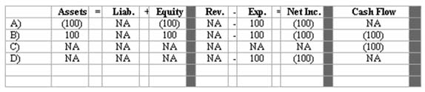
(Points: 2)
A Above.
B Above.
C Above.
D Above.
36. What is the effect on the financial statement model of making a profitable cash sales of inventory to customers?
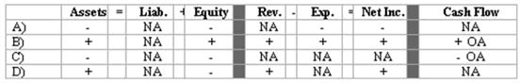
A Above.
B Above.
C Above.
D Above.
32. Which of the following should not be recorded as an expense?
Paid office salaries
Paid factory maintenance costs
Paid product advertising costs
Paid sales commissions

