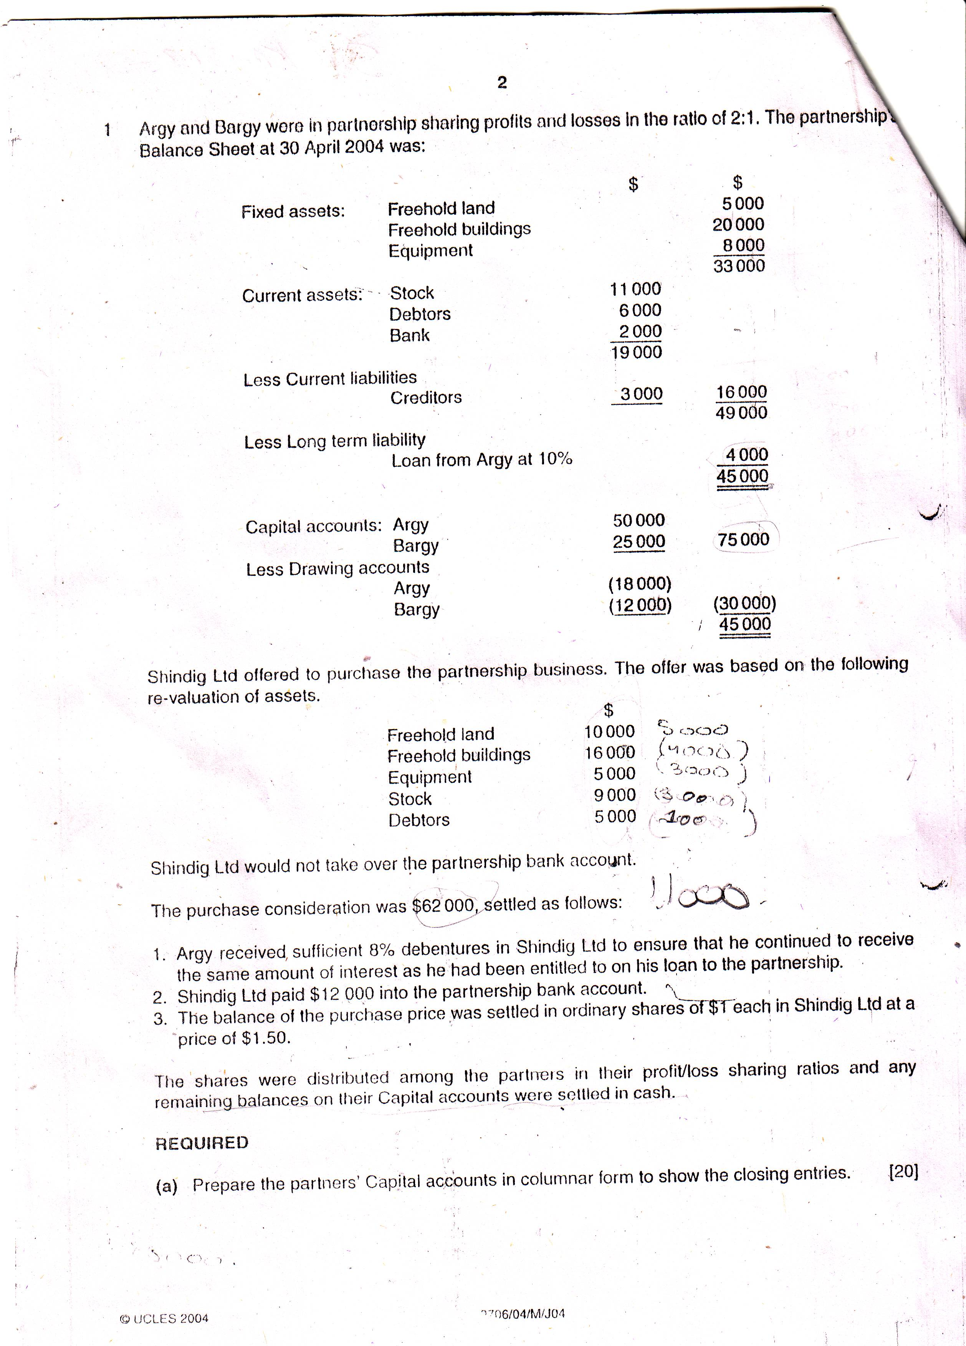

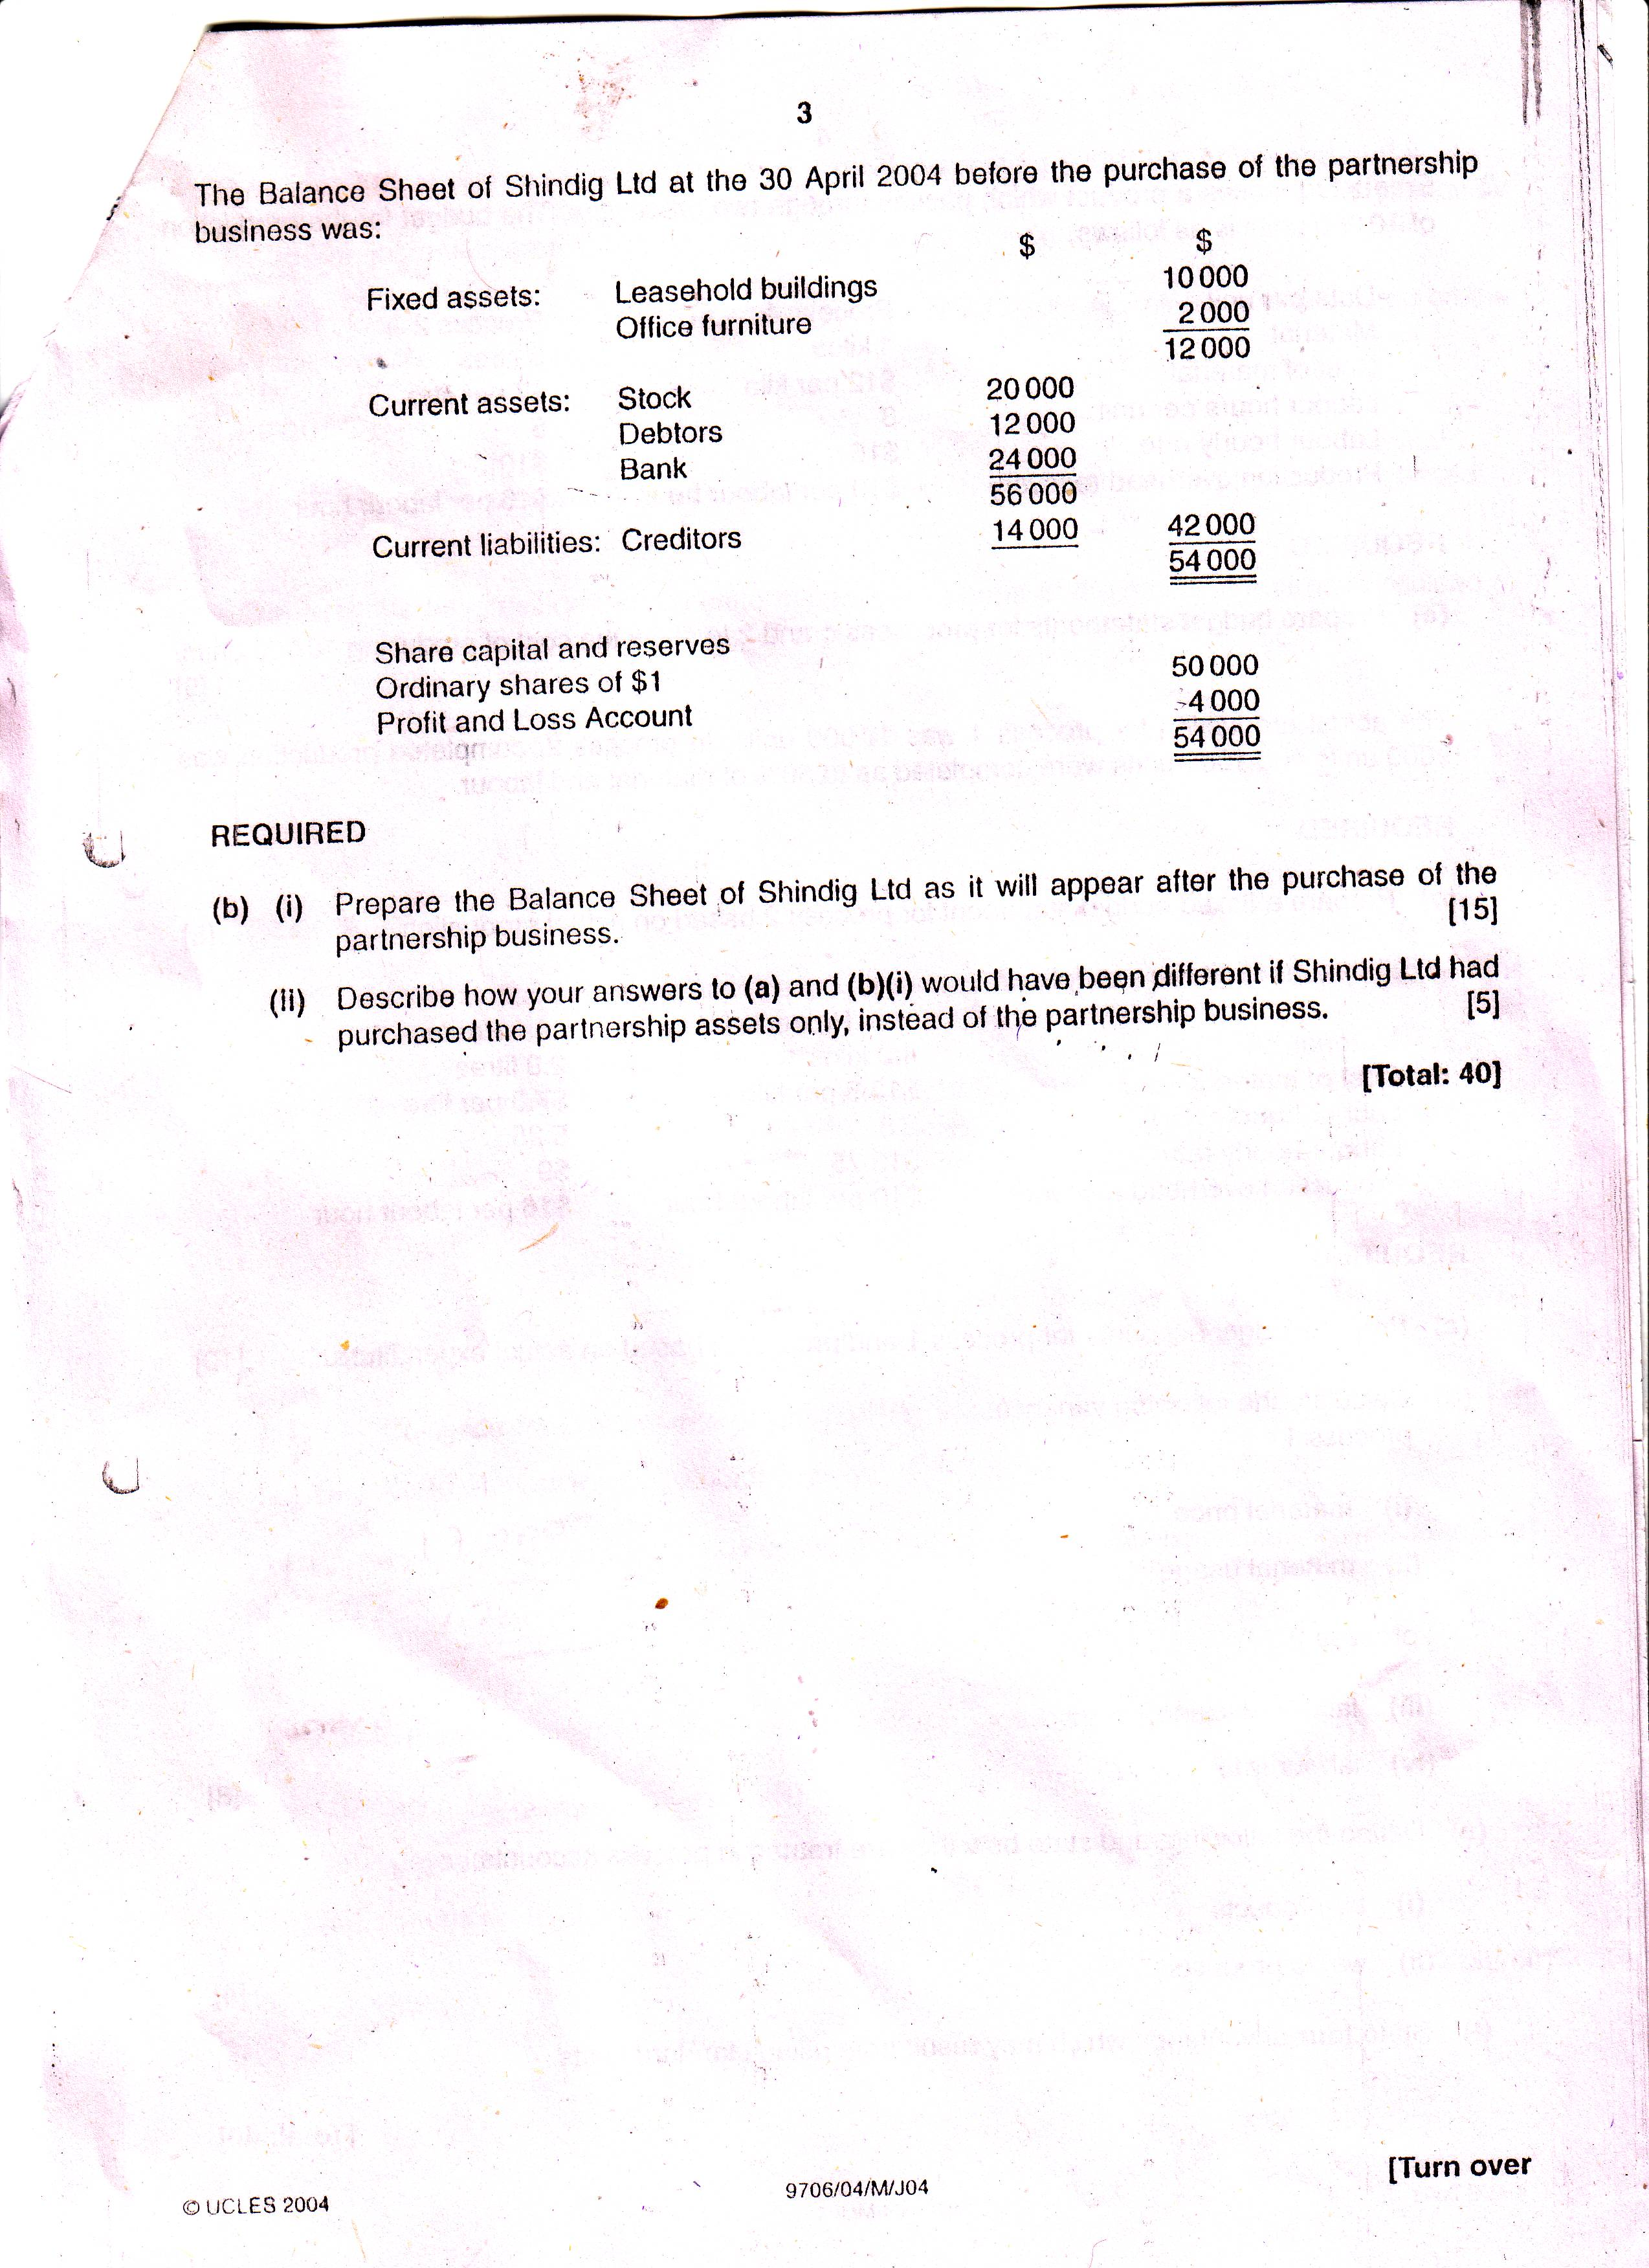

Revaluation Account
 |  |  |  | $ |  |  |  | $
Freehold Building 4000 |  |  |  | 4000 | Freehold land 5000
Equipment |  |  |  | 3000
Stock |  |  |  | 2000 | Loss on Revaluation |  |  | 5000
Debtors |  |  |  | 1000
 |  |  |  | 10000 |  |  |  | 10000
 |  |  |  | Capital Account
 |  |  | Argy | Bargy |  |  | Argy | Bargy
Drawing |  |  | 18000 | 12000 | Balance |  | $50,000 | $25,000
Loan |  |  | 4000 |  | interest |  | 400
ordinary share |  | 17067 |  | 7333
 |  |  | 50400 | 25000 |  |  | 50400 | 25000
 |  |  |  | Shindig Ltd
Balance Sheet as at 30 April 2004
Fixed Assets |  |  |  |  |  | $ | $ | $
Freehold land |  |  |  |  |  |  | 10000
Freehold Building |  | (10000+16000) |  |  |  |  | 26000
Office furniture |  |  |  |  |  |  | 2000
Equipment |  |  |  |  |  |  | 5000
 |  |  |  |  |  |  |  | 43000
Current Assets
Stock (20000+9000) |  |  |  |  |  |  | 29000
Debtors (12000+5000) |  |  |  |  |  |  | 17000
Bank (24000+12000) |  |  |  |  |  |  | 36000
 |  |  |  |  |  |  | 82000
Current Liabilites
Creditors (14000+3000) |  |  |  |  |  |  | 17000
 |  |  |  |  |  |  |  | 65000
 |  |  |  |  |  |  |  | 108000
Share Capital and Reserve
Ordinary Share of $1 each |  |  |  |  |  |  | 67000
Share premium |  |  |  |  |  |  | 8500
Profit and Loss |  |  |  |  |  |  | 4000
Loss on Revaluation |  |  |  |  |  |  | -5000
Debenture |  |  |  |  |  |  | 4000
 |  |  |  |  |  |  |  | 78500

