Question 11:
Which equation matches the graph below?

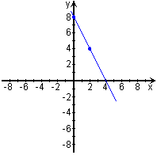
Choices:
- y = -2x - 8
- y = -1/2 x + 8
- y = -2x + 8
- none of these

Solve by graphing. Indicate whether each system is independent, inconsistent, or dependent

12. Y= 3x-4
Y=-2x+1

Solve system by substitution method. Indicate whether each system is independent, inconsistent, or dependent

13. X= 1/8y-1
Y=1/4x+39

Solve each absolute value inequality and graph the solution set

14. 1> ½ I 6-x I – ¾

Graph each compound or absolute value inequality

15. I x-3y I > 9

