Chapter 7:
Conceptual Questions #11,12

11. Engine 1 does twice the work of engine 2. Is it correct to conclude that engine 1 produces twice as much power as engine 2 explain?

12. Engine 1 produces twice the power of engine 2. Is it correct to conclude that engine 1 does twice as much work as engine 2? Explain.

Problems: # 38, 40, 49

- You raise a bucket of water from the bottom of a deep well. If your power output is 108 W, and the mass of the bucket and the water in it is 5.00kg, with what speed can you raise the bucket? Ignore the weight of the rope.

- A kayaker paddles with a power output of 50.0 W to maintain a steady speed of 1.50 m/s.
- Calculate the resistive force exerted by the water on the kayak.
- If the kayaker doubles her power output, and the resistive force due to the water remains the same, by what fact or does the kayakers speed change?

- You push a 67kg box across a floor where the coeffient of kinetic friction is
uk=0.55. The force you exert is horizontal.
- How much power is needed to push the box at a speed of 0.50m/s.
- How much work do you do if you push the box for 35s.

Chapter 8:

Conceptual Question #6

6. An object is thrown upward to a person on a roof. At what point is the object’s kinetic energy at maximum? At what point is the potential energy of the system at maximum? At what locations do these energies have their minimum values?

Conceptual Exercises #12,13

- You ride your bicycle down a hill, maintaining a constant speed the entire time.
- As you ride does the gravitational potential energy of the earth-bike –rider system increase, decrease, or stay the same?
- Does the kinetic energy of you and your bike increase, decrease or stay the same?
- Has the mechanical energy of this system increased, decreased, or remained the same?

- A leaf falls to the ground with a constant speed. Is Ui + Ki greater than, less than, or the same as Uf + Kf for this system?

Problems: 6, 16, 18, 50

- As an Acapulco cliff diver drops to the water from a height of 46m, his gravitational potential energy decreases by 25,000J. What is the diver’s weight in newtons?

- At an amusement park, a swimmer uses water slide to enter the main pool.
If the swimmer starts at rest, slides without friction, and descends through a vertical height of 2.61m, what is her speed at the bottom of the slide?

Find the swimmer’s speed at the bottom of the slide if she starts with an initial speed of 0.840 m/s

18.In a tennis match, a player wins a point by hitting the ball sharply to the ground on the opponent’s side of the net.
(a) If the ball bounces upward from the ground with a speed of 16 m/s and is caught by a fan in the stands with a speed of 12m/s, how high above the court is the fan? Ignore air resistance.
(b) Explain why it is not necessary to know the mass of the tennis ball?

- A sled slides without friction down a small, ice covered hill. If the sled starts from rest at the top of the hill, its speed at the bottom is 7.50 m/s.
- On a second run the sled, starts with a speed of 1.50 m/s at the top. When it reaches the bottom of the hill, is its speed 9.00 m/s, more than 9.00 m/s, or less than 9.00 m/s? Explain??
- Find the speed of the sled at the bottom of the hill after the second run.

Chapter 11 Conceptual Question#1

- Two forces produce the same torgue. Does it follow that they have the same magnitude? Explain.

Problems #2, 6, 22

2.
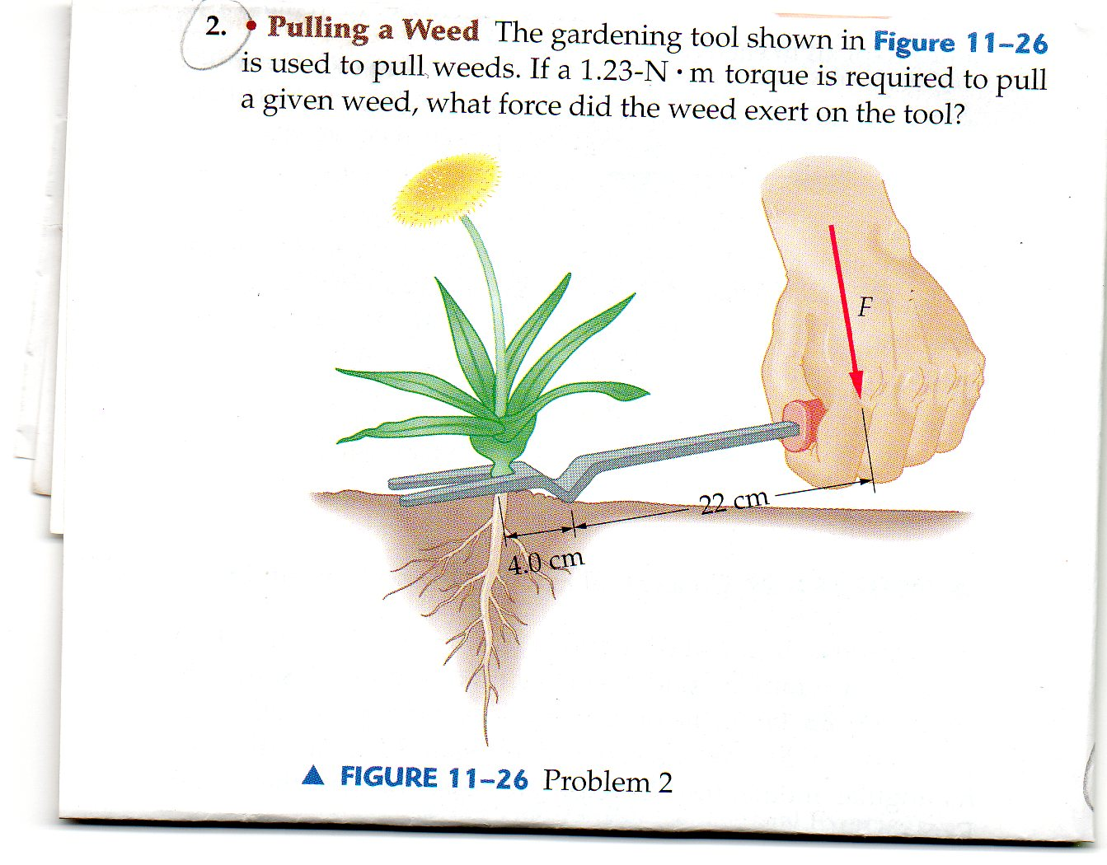

- At the local playground, a 16kg child sits on the end of a horizontal teeter-totter, 1.5m from the pivot point. On the other side of the pivot an adult pushes straight down on the teeter-totter with a force of 95 N . In which direction does the teeter-totter rotate if the adult applies the force at a distance of
- 3.0m
- 2.5m, or
- 2.0 m from the pivot?

- A school yard teeter-totter with a total length of 5.2m and a mass of 36 kg is pivoted at its center. A 18 kg child sits on one end of the teeter-totter.
- Where should a parent push vertically downward with a force of 210N in order to hold the teeter-totter level?
- Where should the parent push with a force of 310 N?
- How would your answers to parts (a) and (b) change if the mass of the teeter-totter were doubled explain?

