- A moving object is acted on by a net force. Give an example of a situation in
Which the object moves
- in the same direction as the net force (b) at right angles to the net force,
(c) in the opposite direction of the net force.

2. A skateboarder on a ramp is accelerated by a nonzero net force. For each of the following statements, state whether it is always true, never true, or sometimes true. (a) The skateboarder is moving in the direction of the net force. (b) The acceleration of the skateboarder is at right angles to the net force. (c) The acceleration of the skateboarder is in the same direction as the net force. (d) The skateboarder is instantaneously at rest.

Numbers 22,23 see diagram see below:

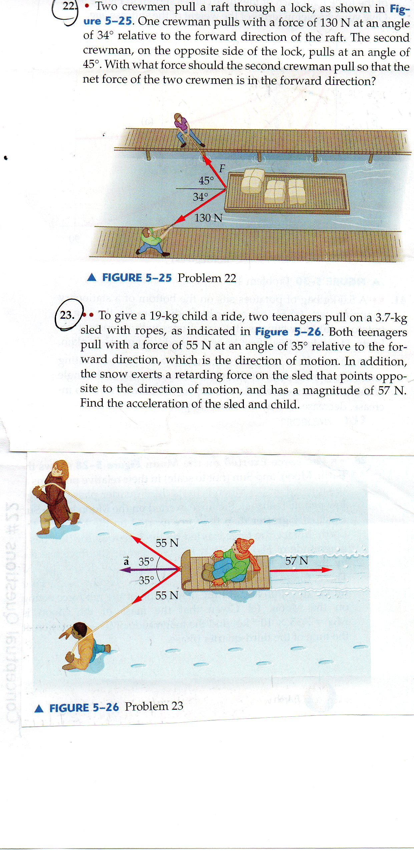

- Is it possible to spin a bucket of water in a vertical circle and none of the water spill when the bucket is upside down? How would you explain this to members of your family?

- Discuss the physics involved in the spin cycle of a washing machine. In
Particular, how is circular motion related to the removal of water from the clothes?

- In a movie Robin hood swings between trees on a vine that is on fire. At the lowest point of his swing, the vine burns through and robin begins to fall. The next shot shows Robin Hood from high up in the trees, showing robin falling straight downward. Would you rate the physics of this scene good, bad, or ugly? Explain.

Number14.

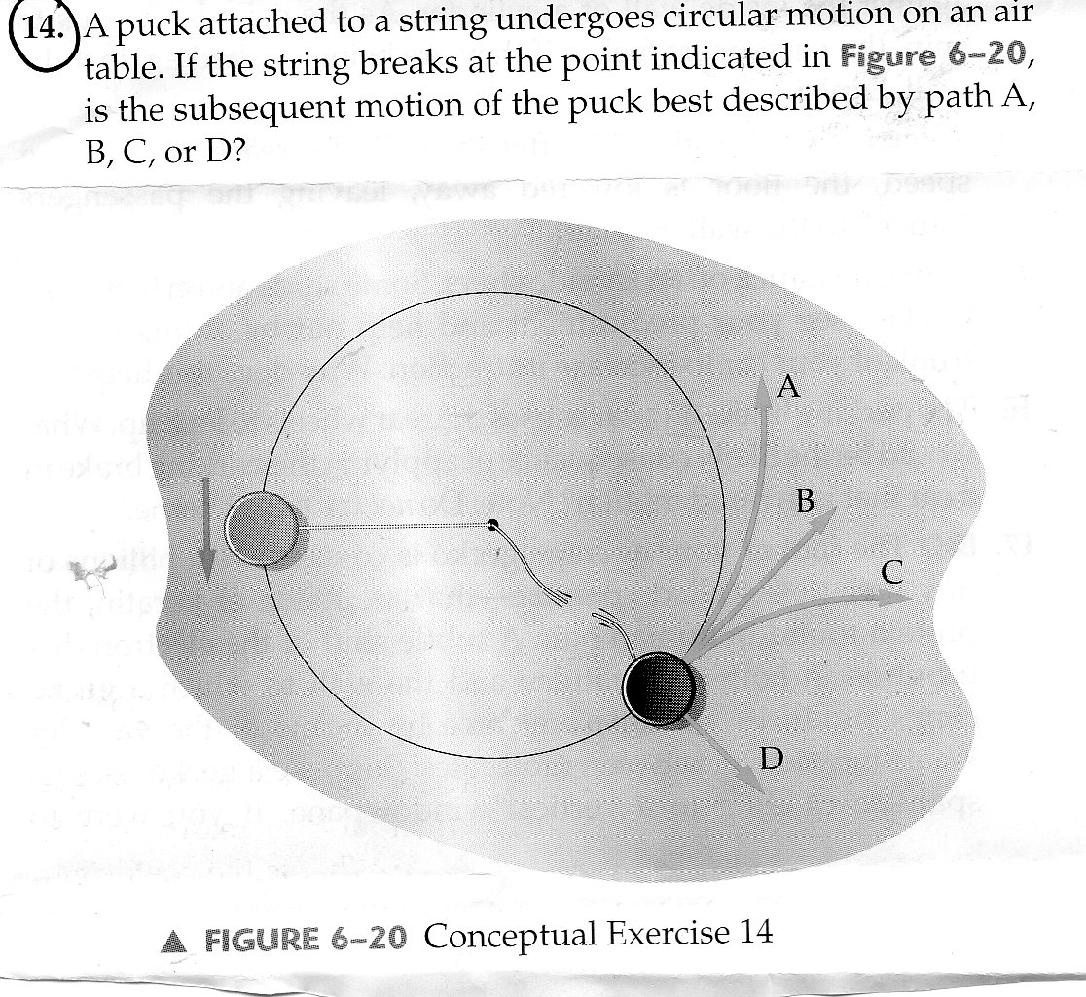

Problems 7. and 8.

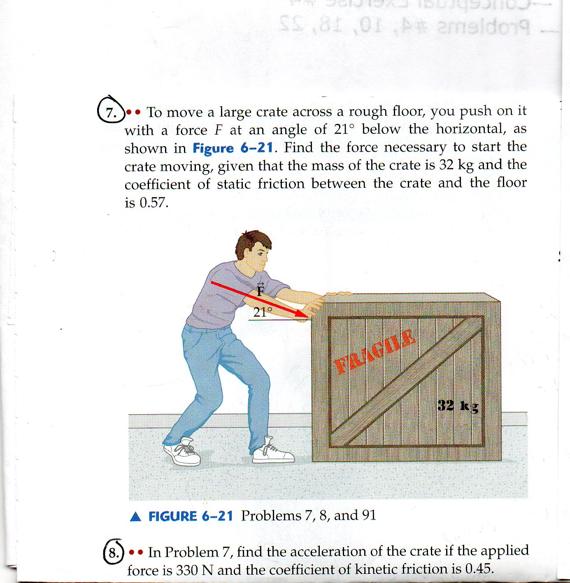

- When you take you 1200kg car out for a spin, you go around a corner of radius 57 m with a speed of 15 m/s . The coefficient of static frication between the car and the road is 0.88, assuming your car doesn’t skid, what is the force exerted on it by the static frication?

- Find the linear speed of the bottom of a test tube in a centrifuge if the centripetal acceleration there is 52,000 times the acceleration of gravity. The distance from the axis of rotation to the bottom of the test-tube is 7.5 cm

- A friend makes a statement, only the total force acting on an object can do work. “Is this statement true or false? If it is true, state why, if it is false, give a counter example.

- The net work done on a certain object zero. What can you say about its speed?

- A pitcher throws a ball at 90mph and the catcher stops it in her glove.
- Is the work done on the ball by the pitcher positive, negative, or zero.
- Is the work done on the ball by the catcher positive, negative, or zero?

- The coefficient of kinetic friction between a suitcase and the floor is 0.26. If the suitcase has a mass of 70.0 kg, how far can it be pushed across the level floor with 640J of work?

- To clean a floor a janitor pushes on a mop handle with a force of 50.0N,
(a) If the mop handle is at an angle of 55 degrees above the horizontal, how much work is required to push the mop 0.50m.
- If the angle the mop handle makes with the horizontal is increased to 65 degrees, does the work done by the janitor increase, decrease, or stay the same? Explain.

- A 0.14 kg pinecone falls 16 m too the ground, where it lands with a speed of 13 m/s.
- With what speed would the pinecone have landed if there had been no air resistance?
- Did air resistance do positive work, negative work, or zero work on the pinecone? Explain.

- A 1300 kg car coasts on a horizontal road with a speed of 18m/s. After crossing an upward, sandy stretch of road 30.0mlong, its speed decreases to 15 m/s.
- Was the net work done on the car positive, negative, or zero? Explain
- Find the magnitude of the average net force on the car in the sandy section.

