Four cargo ships will be used for shipping goods from one port to four other ports (labeled 1, 2, 3, 4). Any ship can be used for making any one of these four trips. However, because of differences in the ships and cargoes, the total cost of loading, transporting, and unloading the goods for the different ship–port combinations varies considerably, as shown in the following table.

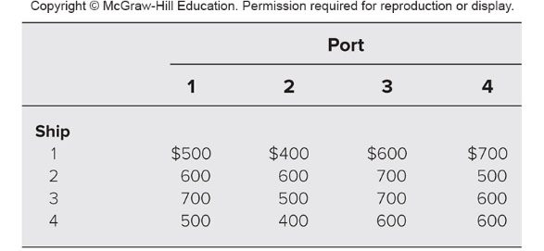

The objective is to assign the four ships to four different ports in such a way as to minimize the total cost for all four shipments. Formulate and solve this problem on a spreadsheet.

