The Cost-Less Corp. supplies its four retail outlets from its four plants. The shipping cost per shipment from each plant to each retail outlet is given below.
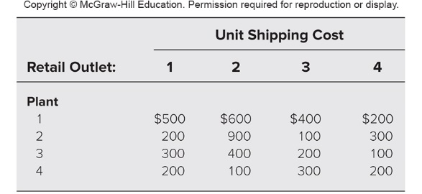
Plants 1, 2, 3, and 4 make 10, 20, 20, and 10 shipments per month, respectively. Retail outlets 1, 2, 3, and 4 need to receive 20, 10, 10, and 20 shipments per month, respectively.
The distribution manager, Randy Smith, now wants to determine the best plan for how many shipments to send from each plant to the respective retail outlets each month. Randy’s objective is to minimize the total shipping cost.
Formulate this problem as a transportation problem on a spreadsheet and then use Solver to obtain an optimal solution.

