A hotel has 500 rooms. During a typical week in the holiday season, the hotel is busy on Monday, Tuesday, Wednesday, and Thursday nights, primarily with business people, but there is generally space available on Friday, Saturday, and Sunday nights.
Hotel management provided the following demand estimates, as shown in Table 8.1:
Assume linear demand functions over the range of all non-negative room rates and demands.

Table 8.1: Demand Estimates

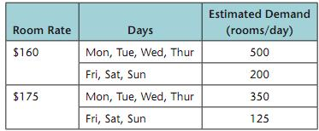

Please briefly answer the following questions

- What is the revenue-maximizing room rate if the hotel posts only a single rate good for any day of the week? What weekly occupancy results?
- What are the revenue-maximizing room rates if the hotel posts a “mid-week” rate good for the peak demand period (MTWT), and a different “weekend” rate good for Friday, Saturday, or Sunday? What is the new weekly occupancy? What is the revenue increase?
- Another option is for the hotel to offer a discounted weekly rate to attract vacationers who will stay for the full week. Management estimates that demand will be 40 per week at $900/week and 160 per week at $800/week. Again, assume a linear demand curve.
- If the hotel posts a weekly rate and a single daily rate (good for any night), what are the revenue-maximizing prices? What is the occupancy rate? What is the revenue gain?
- If the hotel posts three rates: a mid-week rate, a weekend rate, and a weekly rate, what are the revenue-maximizing prices? What is the occupancy rate? What is the revenue gain?

