Let G be a group.
Show that
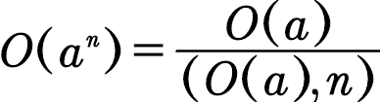
for all 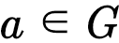
where n is an integer and
(O(a), n) = greatest common divisor of O(a) and n.

