R is the set of integers mod 7 under the addition and multiplication mod 7.
That is, the elements of R are the seven symbols 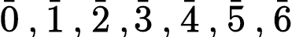 .
where
(1) 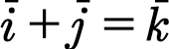 where k is the remainder of I + j on division by 7
(thus for instance, 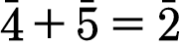 since 4 + 5 = 9 , which when divided by 7
leaves remainder of 2)
(2) 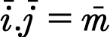 where m is the remainder of ij on division by. 7
(thus , 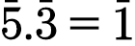 since..5.3 =15 has 1 as remainder on the division by 7)
Prove that R is a commutative ring with unit element.

