- The time it takes for a cheese-and-ham sandwich to be toasted in the Cass ground floor cafeteria appears to be normally distributed. A random sample of the times for toasting 20 such sandwiches had a sample mean of 157 seconds and a sample standard deviation of 28.6 seconds. What is the value of the upper end-point of the 99% confidence interval for the mean time to toast a cheese-and-ham sandwich?

- A sample of 19 independent observations is taken from a normal distribution of unknown mean µ but known variance σ2 = 84.56. The sample mean is 54.88 and the sample variance is 60. What is the width of the 98% confidence interval for µ?

- The useful lifetime of a particular battery is a normally distributed random variable with mean µ = 40 hours and known standard deviation σ = 4 hours. A new chemical composition is introduced aiming to increase the useful lifetime of the battery. It is assumed that the new chemical composition does not affect the standard deviation. After implementing the new process, a random sample of n = 100 batteries has a sample mean useful lifetime of 40.9 hours. Has the new process increased the useful lifetime of the battery? What is the p-value?

- You are given the following information: random sample of independent, normally distributed observations with unknown mean μ and known standard deviation σ = 6. The sample size is n = 26. You wish to test the null hypothesis H0: μ = 40 against the alternative hypothesis Ha: μ < 40. What value c, so that the sample mean Xbar < c, gives probability of Type I error equal to 5%?

- From when I first arrive at the station in the morning, the time T (in minutes) until the train comes is a continuous random variable with density function f(t) = (1/15)*exp(-t/15), t > 0. Calculate the probability that I have to wait between 15 minutes and 30 minutes for the train to arrive.

- The continuous random variable X is said to have a triangular distribution with midpoint a = 24.5 if the density function takes the form given below.
Compute E(X) (you will need to work out the constant c first).
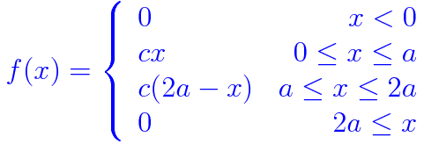

- The median of the probability distribution of a random variable X is that value m which makes the distribution function of X equal to 0.5.
If X has an exponential distribution with rate parameter λ = 8.00, what is the median of the distribution of X?

