Z-Scores and Percentiles (Part 2)
- Below is the a set of temperatures measured in degrees Fahrenheit of randomly selected cities in September. You WILL need to use excel for some of the answers to this question.
68 50 99 73 79 80 82 95 73 84 86 92 45 90

- The mean temperature is:

- The standard deviation of the temperatures is:

- Assuming the temperature is normally distributed, what is the range (low to high) of temperatures for the middle 68% of the cities?

- What is the range (low to high) of temperatures for the middle 95% of the cities?

- Use this range of values in a meaningful sentence.

- Calculate the 25th and 75th percentile of the data set.

- What is the probability of a temperature of over 99 degrees?
Hint: You may want to use the chart below and shade in the region you are concerned with!

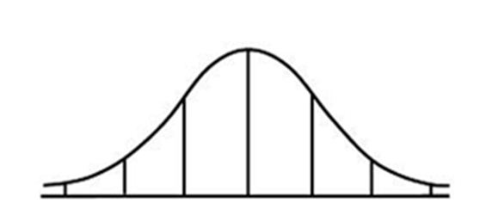

- Find the 25th and 75th percentile of the following data set:
80 90 91 64 70 34 82 61 94 52 80 84

- Professor Ivy’s students have a Mean grade of 69.5 and a Standard Deviation of 6.5.
- If Johnny has an 82 in the class, what would the z-score for Johnny’s grade be?

- What percentile does Johnny’s score put him in?

- Professor Ivy’s students have a Mean grade of 69.5 and a Standard Deviation of 6.5.
- If Johnny has a 62 in the class, what would the z-score for Johnny’s grade be?

- Write a sentence using the idea of a percentile.

- Patients wait 126 days on average for a heart transplant with a standard deviation of 24 days. What proportion waits fewer than 90 days? Diagram this problem by drawing and labeling the bell curve and shading the desired region.

- The life of a 9-volt battery is normally distributed with a mean of $μ=2000$ hours and a standard deviation of $σ=40$ hours. What is the proportion of batteries with an average life of 2100 hours or more?

- People spend an average of 7 hours per day on their home computers with a standard deviation of 1 hour. What proportion spends at least 5 hours per day on their home computers? Write a sentence that states your findings.

- Roadworthy tires last an average of 30,000 miles with a standard deviation of 2500 miles. What proportion of these tires do not last more than 25,000 miles?

- Consider the Roadworthy tires from the problem above. What proportion of tires will last more than 25,000 miles?

- The 9-volt batteries from the earlier problem. What proportion of the batteries are expected to last less than 1950 hours?

- The average annual consumption of ice cream per capita is $μ=16.5$ lbs. in the US.
If the standard deviation is $σ=2.5$ lbs, what proportion of the US consumes less than 10 lbs. per year?
- The average price of a sofa at the warehouse is $450 with a standard deviation of $75. If you wanted to make sure you could save enough money to cover the cost, how much should you save up? Hint: You will be making an educated estimate and JUSTIFING your answer. There is no set answer required but yours should make sense!
- Using the same data as #12, how many people out of 30 could get a sofa for $400 or less?

