Quantitative Reasoning Linear Models, Scatterplots, Exponential Growth, Exponential Decay

Questions 1-3. You invest $230 to start a sandwich stand and decide to charge $4.25 per sandwich.

- Set up a Linear Model that determines your profit or loss based on the number of sandwiches.

- How much money will you make if you sell 75 sandwiches? (round to the nearest cent).

- How many sandwiches must you sell to make a $100 profit? (round to nearest sandwich)

Questions 4-6. A can of soda in 1972 costs $0.10, by 2012 it costs $1.25.
- Find the rate at which the cost of a can of soda increase over this time period. (round to the hundred thousandth place).

- Construct a linear model that can be used to predict the cots of soda. (round to the hundred thousandth place)

- Use your linear model to predict the cost of a soda in 2014. (round to the nearest cent)

Questions 7-11. A scatterplot below was made using the annual CPI rate from 1960 to 2014. A trend line was added.
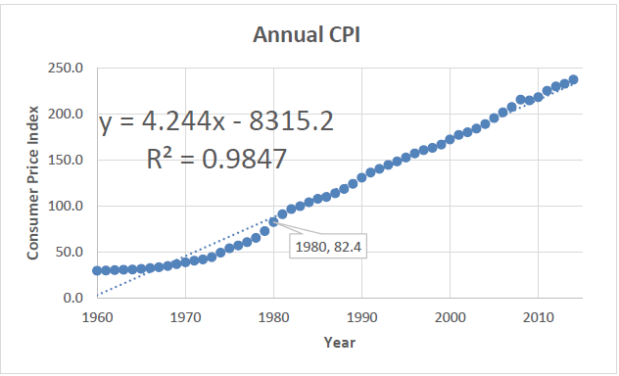

- Use the trend line equation to estimate the CPI for 1980. (round to the hundredths place)

- How does this value compare with the actual CPI for 1980? Use absolute or relative change in your answer.

- Interpret the meaning of the slope of the trend line.

- What is the linear correlation coefficient? (round to the ten thousandths place)

- Should we use this model to predict CPI for 2030? Why or Why not?

Questions 12-15. A species of beetles grows 32% every year. Suppose 100 beetles are released into a field.

- Construct an exponential model for this population.

- How many beetles will there be in 10 years? (round to the nearest beetles)

- How many beetles will there be in 20 years? (round to the nearest beetles)

- About when will there be 100,000 beetles?

Questions 16-18. The landscaper pours 200 gallons of herbicide in a pond. The herbicide degrades 10% each week.

- Write an equation to find the amount of herbicide in any given week.

- How much will be in the pond after 1 week? (round to the nearest gallon)

- The landscaper will put another dose in the pond when the herbicide level drops below 50 gallons. In about how many weeks will he need to add more herbicide?

