- Draw the complete detail of a network diagram corresponding to the following information.

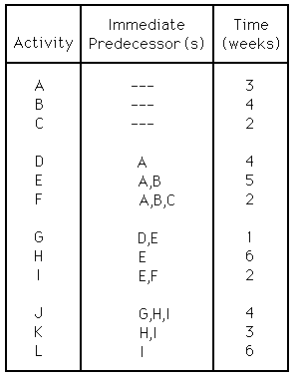
              - What is the critical path for this project?
              - Suppose activity D can be shortened from four days to one day. Assume all other activity times remain the same. How much shorter will the total project earliest completion time become?
              - Suppose activity I is delayed, taking eight days to complete instead of two days. Assume all other activity times remain the same. How much longer will the total project earliest completion time become?
  - What is the latest start time for activity A?

