Polar Art Project

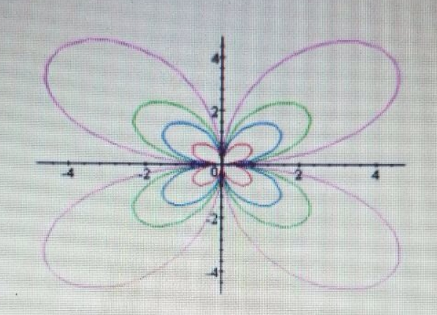

Graph of r = b sin (kθ) when k = 2 (even number), for varying values of b = 1, 2, 3, 6

Instructions: The major point of this project is that it convincingly communicate what you have found to be important from your investigation. Your write-up should be typed, double spaced, and include graphs (embedded in the document). Use complete sentences. Clarity, accurate mathematics, terminology and correctness of responses will determine the grade. You can use Desmos, Fooplot or Wolframalpha for these investigations.

Investigate graphs of the polar equations r = b cos (kθ) and r = b sin (kθ) for the following two cases:

- Case I. For b = 1, 2, 3, 6 when k = even number
- Case II. For b = 1, 2, 3, 6 when k = odd number

Note: Try different even & odd numbers to ascertain that the conclusion is correct.

In your write-up do make sure to address the following questions:

- How many leaves do the resulting roses have? Are the leaves equal in size? What is the relationship between “k” and the number of leaves?
- How does varying “b” affect the graph?
- What can you say about the symmetry of the graphs?

