The time to cook a bag of microwave popcorn is normally distributed with a mean of 3.5 minutes and a standard deviation of 0.6 minute.
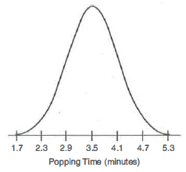
Suppose that you randomly select a microwave popcorn bag from the sample. Use the given information and the distribution to answer each question. Explain your reasoning.
- What percent of microwave popcorn bags will properly cook a timespan that is between 2.9 minutes and 4.1 minutes?
- What percent of microwave popcorn bags will properly cook in a timespan that is more than 3.5 minutes?
- What percent of microwave popcorn bags will properly cook in a timespan that is less than 2.3 minutes?
- What percent of microwave popcorn bags will properly cook in a timespan that is more than 2.9 minutes?
- What percent of microwave popcorn bags will properly cook a timespan that is between 4.7 minutes and 5.3 minutes?

