A researcher recorded the birth weights of a sample of newborn babies. The average birth weight was 7.2 pounds and the standard deviation was 0.9 pound. The birth weights follow a normal distribution.
- Label the number line so that the curve is a normal curve and follows the properties of the normal distribution. Include 3 standard deviations above and below the mean.

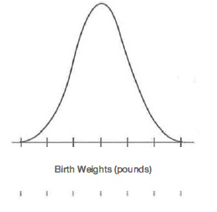

- Determine the percent of newborns that weight between 2 standard deviations below the mean and 2 standard deviations above the mean.

- Determine the percent of newborns that weight less than the mean.

- Determine the percent of newborns that weight between 1 standard deviation above the mean and 3 standard deviations above the mean.

- Approximately what percent of newborns weighed between 4.5 pounds and 9.9 pounds?

- Approximately what percent of newborns weight more than 9 pounds?

- Approximately what percent of newborns weighed less than 6.3 pounds?

