DATA-DRIVEN DECISION MAKING
The chief cashier of a bank must manage the cash holding to gain interest by investing excess cash where possible, but at the same time keep sufficient cash on hand to meet the bank’s needs. A major issue for the chief cashier is the uncertainty that results from the Federal Reserve Board’s (the Fed’s) clearing balance. The clearing balance is the difference between the dollar value of checks written by the bank’s customers and cleared through the Fed, and the dollar value of checks received but written on other banks and clear through the Fed.
The chief cashier has recorded the last eight weeks of clearing balances (a longer period is available, but we will use just eight weeks here). The 40 observations of daily check clearings are shown in the chart below.
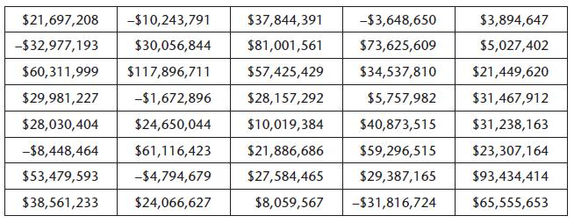

1. Using Excel please provide point and interval estimates of the mean daily clearing balance.
2. Using Excel please provide point and interval predictions (or forecasts) of tomorrow’s clearing balance.

