TQME 2: Maintainability Engineering
- An ultrasonic beam travels through a 4-inch thick aluminum alloy plate and strikes a body of water. The following data for aluminum alloy and water are given.

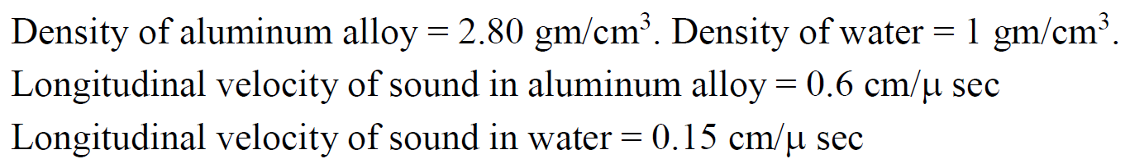

- Calculate the acoustic impedances of aluminum alloy and water. Indicate units
- Calculate the percent of ultrasonic wave energy reflected
- Calculate the percent of ultrasonic wave energy transmitted

- The rotational speed of a turbine shaft is 3600 RPM
- Calculate the rotational speed in Hz.
- Give an example of a non-synchronous frequency of shaft speed (Hz)
- Give an example of a sub-synchronous frequency of shaft speed (Hz)
- Give an example of a harmonic frequency of shaft speed (Hz)

- The drive gear in a gearbox has 32 teeth. It drives a pinion with 16 teeth. The drive
gear shaft speed is 180 RPM. Calculate the following.
- Drive gear shaft speed in Hz
- Tooth mesh frequency (Hz)
- Rotational speed of the pinion (Hz)

- The ball pass frequency of the inner race (BPFI) in a ball bearing is given by

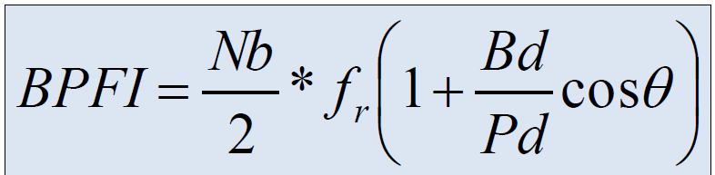

The following parameters are given: Bd = 8 mm, Pd = 40 mm, θ = 0°.
(a) Define (in words) ball pass frequency of the inner race (BPFI)
(b) Simplify the expression for BPFO in terms of Nb and fr using the above data
(c) If Nb = 9 and fr = 30 Hz, calculate the BPFI (in Hz) for this bearing.

- The figure below shows the motor current pattern during the open-to-close stroke of a motor-operated valve. Match the letters B, C, and D in the figure with the statements below.
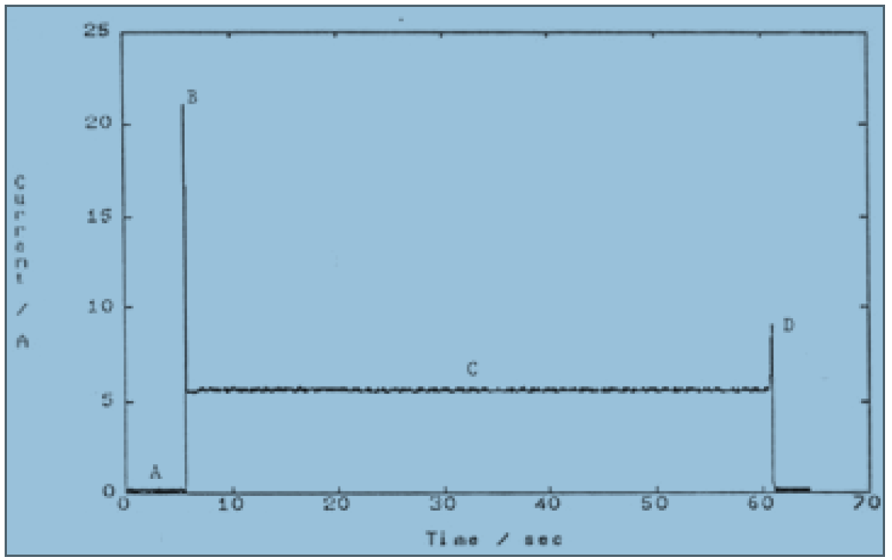

(a)_____ Valve seating current at the end of the stroke.
(b) _____ Motor inrush current upon starting.
(c) _____ The normal running current

