TQME 1: Maintainability Engineering

- State four important and distinct equipment condition monitoring technologies used in predictive maintenance (condition-based maintenance)

- State four important causes of vibration in rotating machinery. Each of the causes must be distinguishable as a function of the shaft rotating speed.

- Explain the principle of pulse-echo ultrasonic testing of a metallic block specimen. Use a figure to illustrate the method and state how a defect at a location within the block can be detected by this approach.

- What is the most common type of transducer material used in an ultrasonic probe?

- The graph below shows vibration signal (measured by an accelerometer placed vertical to the shaft axis) frequency spectrum characteristic of a ball bearing. (frequency is in ‘order’) 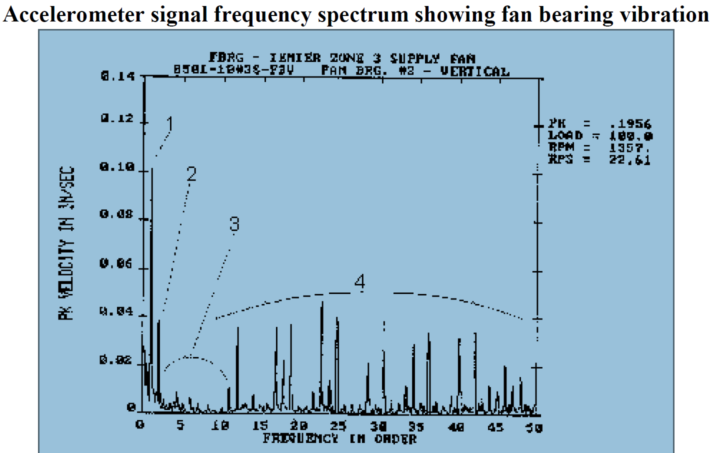
i. _____ Pointer 1 on the figure indicates
A. Parallel misalignment
B. Imbalance
C. Ball bearing defects.
D. Looseness

ii. _____ Pointer 2 on the figure indicates
A. Angular misalignment
B. Parallel misalignment
C. Imbalance
D. Looseness

iii. _____ Pointer 3 on the figure indicates
A. Looseness
B. Ball bearing defects
C. Parallel misalignment
D. Angular misalignment

iv. _____ Pointer 4 on the figure indicates
A. Looseness
B. Combined angular and parallel misalignment
C. Ball bearing defect frequencies
D. Thermal defects

45. _____ Pointer 4 on the figure indicates
A. Looseness
B. Combined angular and parallel misalignment
C. Ball bearing defect frequencies
D. Thermal defects

