TQM 5
1. What are the three important technical dimensions of lubrication oil analysis?
2. Define Total Acid Number (TAN) and Total Base Number (TBN) of lubrication oil and state their importance in machinery lubrication (this may require internet search).
3. An ultrasonic beam travels through an 8-inch thick carbon steel plate and strikes a body of water. The following data for carbon steel and water are given.
Density of carbon steel = 7.85 gm/cm3
Density of water = 1 gm/cm3
Longitudinal velocity of sound in carbon steel = 0.594 cm/µ sec
Longitudinal velocity of sound in water = 0.149 cm/µ sec
(a) Calculate the acoustic impedances of carbon steel and water. Indicate units.
(b) Calculate the percent of ultrasonic wave energy reflected.
(c) Calculate the percent of ultrasonic wave energy transmitted.
TQ6
4. Assume a system (not the system in problem 1!) has three components: X, Y, Z. If the rank order uncertainty is given as:
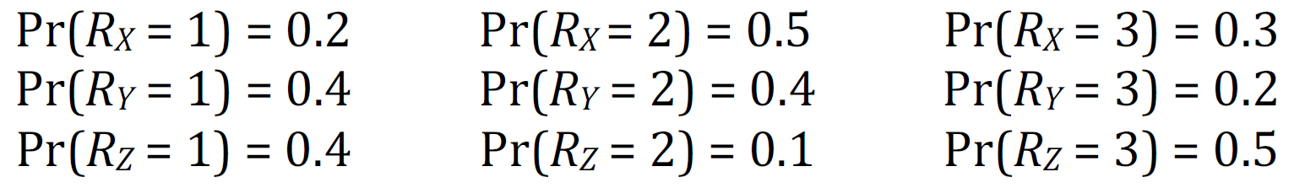
Give the relative ranking of the three components.

