It’s Not New, It’s Recycled
Composition of Functions

Sophia is using an electric air pump to inflate a spherical balloon that has a maximum volume of 2250 cubic inches. The pump increases the volume of the balloon by 7.5 cubic inches per second.
26. Write the function V(t) to represent the volume of the balloon as a function of time.

27. The equation $V=\frac{4}{3}πr^{3}$ is the formula for the volume of a sphere with a radius, r, in inches. Use this equation to write the function r(V) which represents the radius of the spherical balloon as a function of the volume, V.

28. Graph the functions V(t) and r(V) on the grids provided. 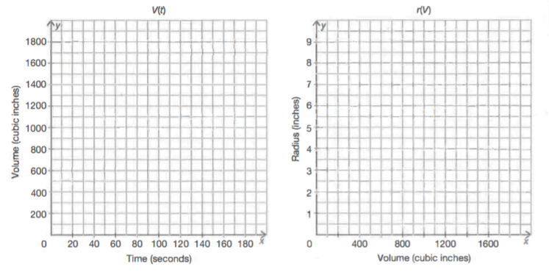
29. Use the graphs in part c to determine (r o V)(100). Explain your reasoning.

30. Write the composition (r o V)(t).

31. Determine the domain of the composite function (r o V)(t) in terms of the problem situation.

32. Determine (r o V)(60). Explain what this value means in terms of the problem situation.

33. Determine the radius of the balloon after Sophia has inflated it for 3 minutes.

34. Determine the maximum radius of the balloon. Explain your reasoning.

