TQ6 Importance Ranking

- For a given initiating event, a system has two hazard barriers, shown below. After an initiating event, if barrier X succeeds, the system is safe. If both barriers fail, then an
Undesirable consequence occurs (100 injuries). If barrier X fails, but barrier Y succeeds, the consequence is less severe (10 injuries). Draw the event tree for this
Situation (label all sequences and consequences). Find the minimum cut sets for each scenario.

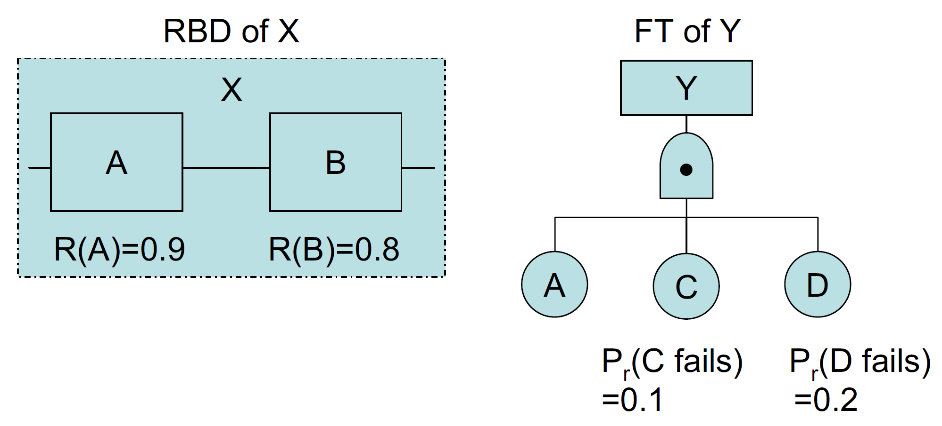

- For the situation described in problem 1 above: if the frequency of the initiating event is 0.25/year, calculate the system risk.

- Still for the situation described in problem 1 above: calculate the Birnbaum, Risk Achievement Worth, Risk Reduction Worth and Fussell-Vessely Importance Measures for components A, B, C, and D.

- Assume a system (not the system in problem 1!) has three components: X, Y, Z. If the rank order uncertainty is given as:
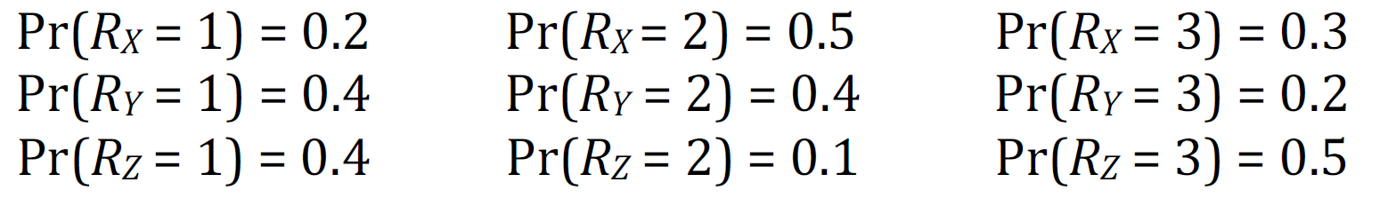

Give the relative ranking of the three components.

