TQ4
1. A signal is sampled at 100 samples/sec. It was later found that the original signal
contained a frequency component at 60 Hz. Calculate the frequency at which the aliasing effect is seen in the power spectrum in the frequency range [0 50] Hz.

2. The stiffness, k, of a linear spring used for vibration damping is 120 lbf/inch. Calculate
the resisting force on the spring for a deflection of 0.2 inch.

3. The drive gear in a gearbox has 32 teeth. It drives a pinion with 16 teeth. The drive
shaft speed is 180 RPM. Calculate the following.
(a) Drive gear shaft speed (Hz)
(a) Tooth mesh frequency (Hz)
(c) Rotational speed of the pinion (Hz)

4. Calculate the belt pass frequency for a belt drive, with a total belt length of 200 inch.
The belt passes over a pulley of diameter 20 inch with a shaft frequency of 1000
RPM. Express your answer in cycles per minute.

5. The ball pass frequency of the outer race (BPFO) in a ball bearing is given by
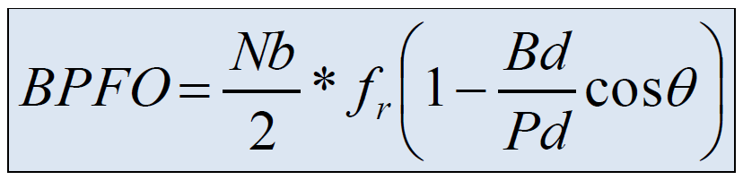
The following parameters are given: Bd = 8 mm, Pd = 40 mm, θ = 0°.
(a) Simplify the expression for BPFO in terms of Nb and fr.
(b) If Nb = 9 and fr = 30 Hz, calculate the BPFO for this bearing.
(c) What does BPFO indicate if there is a defect in the bearing outer race?

