A corporation has the following balance sheet items for the year ending December 31, 2011:

Cash $15,000
Accounts Receivable 20,000
Inventory 45,000
Prepaid Expenses 10,000
Property Plant and Equipment 80,000
Total Assets $170,000

Accounts Payables 30,000
Long Term Notes Payable 70,000
Stockholders' Equity 70,000
Total Liabilities and Equity $170,000

The income statement for the year ending December 31, 2011 is as follows:

Sales $110,000
Cost of Goods Sold (50,000)
Gross Margin $ 60,000
Selling Expenses (20,000)
Administrative Expenses (10,000)
Interest Expenses ( 5,000)
Net Income $25,000
Calculate the current ratio
5.67
3
2.67
1.7

Calculate the acid test/quick ratio
1
2.67
3
5.67

Calculate the debt to equity ratio
1
1.43
.43
.17

Calculate the profit margin ratio
.23
4.4
.55
1.83

Calculate the times interest earned ratio
6
5
.2
22

A corporation is considering the purchase of a new equipment costing $90,000. The projected after-tax annual net income from the equipment is $3,600, after deducting $30,000 depreciation. Assume that revenue is to be received at each year-end, and the machine has a useful life of three years with zero salvage value. Management requires a 12% return on its investments. What is the net present value of this machine? (use tables on next page)
$60,444
$80,700
$(9,300)
$(88,560)
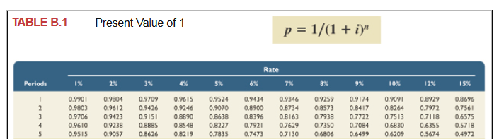
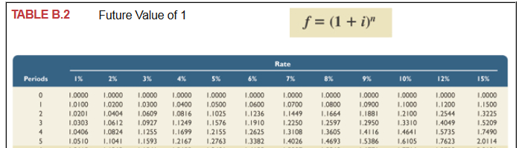
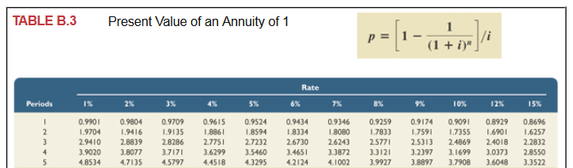
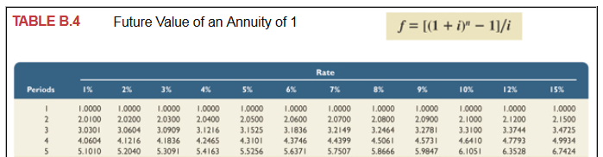

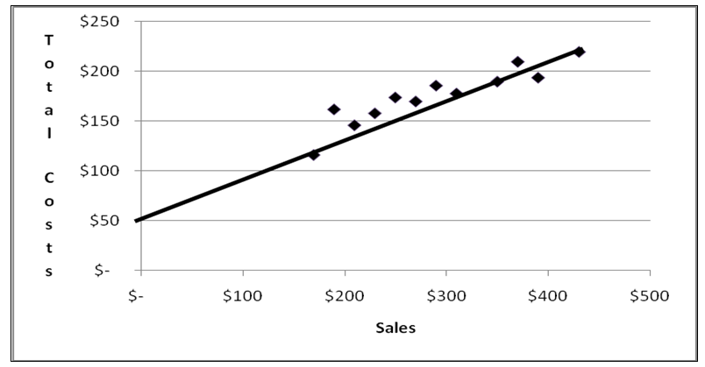
What is the estimated fixed costs based upon the scattergraph?
$300
$50
$225
$175

