TQ3
- For the fault tree given below,
- Find the minimum cut sets
- If the probability of each basic event is 0.10, what is the approximate top event probability? Using the minimum cut sets, what is the exact top event probability?
- Find a set of mutually exclusive cut sets (using a BDD) and use those to calculate the exact top event probability.

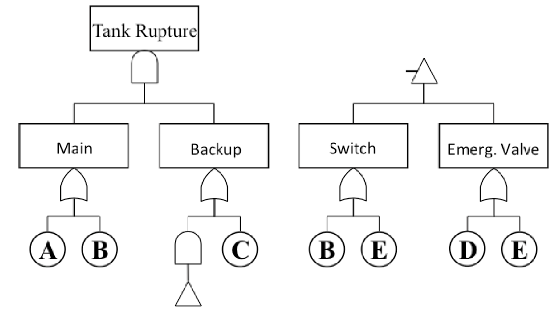

- If an accident requires occurrence of event I followed by event B or C so that a major consequence occurs:
- Develop an event tree to depict all scenarios that are possible. Assume event B is triggered first.
- If the frequency of event I is 0.1 per year and B and C may be obtained from the following fault tree, with probabilities assigned to each basic event, determine the frequency of each scenario.
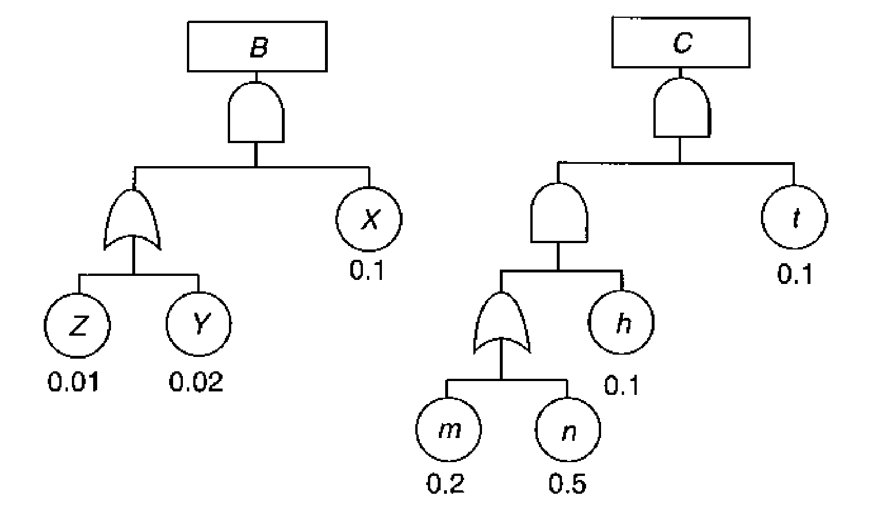

- If the consequence of each accident scenario is 100 injuries, what is the total risk of the accident?

- Calculate the exact probability of 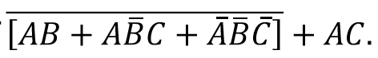
Assume that A, B, and C are independent, but not mutually exclusive. P(A) = 0.4,
P(B) = 0.25, P(C) = 0.8

