TQ2
- Suppose the failure time history of a component is given (where downward -facing arrows indicate failure times):

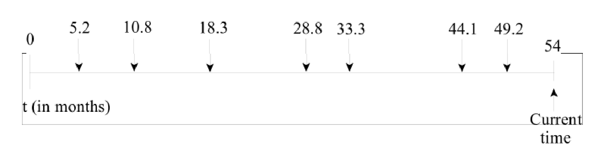
- Assume the failure process follows a NHPP with λ(t) = exp(α+βt). Estimate the model parameters α and β using the MLE.
- What is the expected number of failures from the current time until 72 months?
- Check if the failure process has a time trend [α = 0.1]. If it does not, find the ROCOF.

- Suppose the following data were observed in a repairable system:
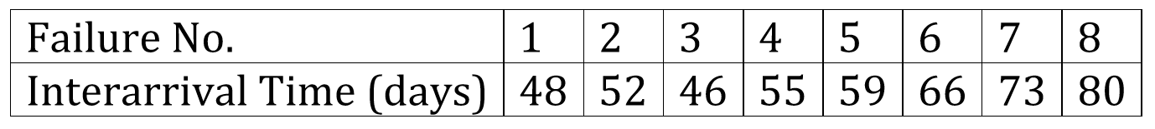
- Assume the failure process follows a renewal process and the interarrival time have
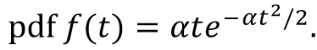
Estimate the parameter α based on the failure data. (Hint: find the MLE)
- Now, assume that the failure process follows a renewal process with an exponentially distributed interarrival time 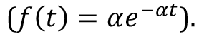 Estimate the value of α.

- The failure time distribution of a product can be described by the following CDF:
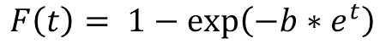
Where b is the parameter to be estimated. We have observed the following failure times (note + means that the time corresponds to a censored unit – i.e., the component has not failed at the point in time): 10, 12, 15, 18+, 23, 28, 35, 44, 45+, 51, 56+. Construct the likelihood function and the MLF of b.

- Seven Pumps have failure times (in months) of 15.1, 10.7, 8.8, 11.3, 12.6, 14.4, and 8.7. Assume the pump failure follows an exponential distribution.
- Find the MLF of λ.
- Estimate the reliability of a pump at t = 12 months.
- Calculate the 95% two-sided interval of λ

- The following data were collected by Frank Proschan in 1983. Operating hours to first failure of an engine cooling part in 13 aircrafts were:
Do these data support an increasing, decreasing, or constant failure rate assumption?

