- Draw a SIPOC diagram for a small, independent bike repair shop that specializes in variety of services. Do not write any narrative.

Manufacturers Labor As Stated Below Customers Young Adults
Suppliers Spare Parts Paperwork School Children
Capital Payments Athletes
Equipment Repaired Bicycles 2nd Hand Bicycle Shops

- Assume you are a manager of a small independent retail shop. Write one statement of operations objective for: (1) cost, (2) quality, (3) delivery, and (4) flexibility. (Make up mock-up numbers as necessary) (2 points)

Statement of Operational Objective:
Cost:
- Improve the bottom-line by increasing the margins by 20%
Quality:
- Introduce guarantees on perishables to boost customer confidence in the products
Delivery:
- Provide customers with delivery tracking numbers for online tracking of their purchased products
Flexibility:
- Introduce online shopping by creating a website with a shopping cart for customer convenience

- What is the concurrent engineering approach to product design? Explain by one example.

3. A concurrent engineering approach to product design is the methodology that promotes the maximization of product quality, minimization of lead times and cost reduction. For example, when Boeing company created the Boeing 777 successor to the Boeing 767, the company applied concurrent engineering techniques to reduce the time compression to 1.5 years – in the light of this time reduction, the company managed to lower the advantage of its competitor Air Industrie.

- Assume you are a local pizza store owner. What can be your distinctive operations competence? Explain by one example.

4. Distinctive operations competence for a pizza store indicates the core competence a company has over its competitors. For example: We deliver piping hot pizza every time, if the heat indicator on the box turns black from red, your pizza is free.

- A clothes dryer manufacturer did a survey of its 800 customers. It was found that the customers wanted four important attributes in a washer: (1) good looking, (2) easy to operate, (3) energy efficient and (4) noise/vibration free.
Based on these customer requirement attributes, create (draw) a mocked up QFD diagram. Fill up all QFD parts. Label everything. You may have to make up data or numbers.

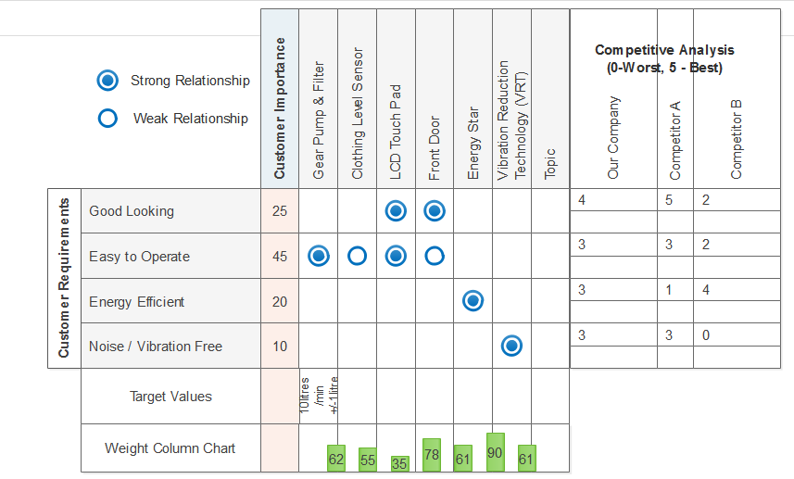

- Give one example of a product that is of modular design. Explain why it is modular.

6. A computer is of modular design. A computer is of modular design because it is assembled by several different sub-systems called modules that are developed separately. In this sense, a computer can be upgraded or repaired by replacing or adding a simple module rather than replacing the whole computer thus promoting flexibility and cost reduction.

- Give one example of mass customization. Explain why it is mass customization.

7. Chem Station in Ohio is an example of a company that employs mass customization. The company studies each customer’s washing habits and requirements and manufactures detergents to match their need (Martin, 2015).

- A company that totally custom designs and produces its product does not need a strong capability to forecast short term demand. Why?

A company that totally custom designs and produces its product does not need a strong capability to forecast short term demand because the product being designed is tailored specifically for the customer in concern meaning that the same product will not be marketed to another customer.

- You are a service company and you choose to offer your service with a “high degree of customer contact”. What are two key consequences of this choice? Give one example of each.

Service companies with a high degree of customer contact have more difficulty in providing first-class personal customer service while at the same time maximising opportunity for increased revenue, for example, service offered at a food outlet tends to be rushed and straight-to-the-point as opposed to the personalized service offered in a gourmet restaurant as the customer-to-waiter ratio is much higher for a food outlet. Another consequence is that the level of risk encountered is higher when dealing with a high degree of customer contact. An example is the risk of legal action being taken against the company by customers for various legal and ethical breaches, like negligence or discrimination – in low customer contact service companies, the risk is much lower.

- Give one example of a service guarantee.

10. One example of a service guarantee is based on the 2015 McDonald’s promotional offer which states that customers would get their breakfast in 60 seconds or they would receive a coupon for a free sandwich (Little, 2015).

- Give one example of service recovery.

11. An example of service recovery is when South West airlines proactively identified customers who had erroneously paid for faulty in-flight Wi-Fi services. Each affected customer was sent an email and a credit card refund for the total cost after the flight much to the delight of the affected customers. This is in addition to the free drinks also offered for the inconvenience (Toporek, 2014).
12. What is the 5S framework? Give example of each “S.”
The 5S framework is an organization methodology that employs the use of 5 Japanese words to strategize the manner in which a work space is laid out for effectiveness and efficiency purposes. The 5S’s stand for:
Sort – The removal of clutter from a work area
Set in order – The arranging of all tools and equipment in such a manner that promotes smooth workflow and a safe working environment.
Shine – the maintenance of the work space by cleaning and promoting hygiene for a safe and pleasant working environment
Standardize- Maintain order in the workplace according to standardized best practices
Sustain – the implementation of training, self-discipline and auditing procedures on a regular basis in line with set goals. Progress reports are generated monthly.

13. Your company makes Camping Tents. Give one example for each of the following components of cost of quality in your operation:
a. Internal failure cost – scrap tent material (remnant material)
b. External failure cost – returns (for faulty tents)
c. Appraisal cost – product quality audits
d. Prevention cost – quality control training

14. What is one major difference between Malcolm Baldrige Award and ISO 9000 series of standard?
The ISO 9000 quality management standard is internationally recognised whilst the Malcolm Baldridge award is a performance excellence and innovation standard mainly used in the U.S.

15. There is no difference in Kaizen and BPR.
True of False

16. Cause effect diagram proves root causes.
True or False

17. Pareto chart separates "significant few from trivial many"
True or False

18. Enterprise Resource Planning (ERP) drives many transaction processes within a company and its modules cover finance, accounting, marketing, operations, engineering, distribution, etc. aspects.
True or False

19. ERP has a broader scope in transaction management than MRP.
True or False

20. The output of MRP is: (1) Shop orders and (2) Purchase orders. (1 point) True or False

21. What are the five (5) basic principles of Lean Thinking as per Womack and Jones?

Reduced cost through reduced inventory levels
Higher quality
Reduced lead time
Increased productivity
Reduced amounts of waste

22. What are 7 wastes (mudas) in any process.
Overproduction – Is the output, or the product produced according to consumer demand, or is the organization producing in excess?
2.Waiting – How much lag time is there between production steps?
3.Inventory (work in progress) – Are your supply levels and work in progress inventories too high?
4.Transportation – pertains to the effectiveness of a delivery system? Is the transportation of supplies operating efficiently?
5.Over-processing – Do you work on the product too many times, or otherwise work inefficiently?
6.Motion – Do people and equipment move between tasks efficiently?
7.Defects – How much time do you spend finding and fixing production mistakes?

23. A process has USL = 22.5, LSL = 17.5; mean = 20; and standard deviation = 3.0
(a) What is Cp?
Cp = (USL –LSL)/(6* std.dev)
Cp = (22.5-17.5)/(6*3.0)
Cp = 0.278

(b) Cpk?
Cpk = min {[(USL-mean)/(3*std.dev)] , [(mean-LSL)/(3*std.dev)]}
Cpk = min {[(22.5-20)/(3*3.0)] , [(20-17.5)/(3*3.0)]}
Cpk = min (0.278 , 0.278)
Cpk = 0.278
24. A company making coffee tables makes them in three sizes- small, medium, and large for their Nova model. How many master schedules would be necessary for the material requirements planning of the Nova line? (1 point) _____1____

25. A machine has MTTR = 10 hour; and MTBF = 150 hours. What is its availability?
_____0.9375_____

26. A factory has Average Demand of 2500 units and Capacity of 2000 units. What is its Capacity Cushion? _20%_________

27 A factory has average output of 220 units per week and a nominal capacity of 300 units per week. What is the utilization? _73.33%_________

28. A garment factory making jackets has three sequential departments doing Cutting, Sewing and Packaging. The defect rates are 3%, 7% and 10% respectively. (Show calculations with 3 decimal accuracy)
1. What is the overall first pass defect rate of the factory? __0.067_______
2. What is the overall first pass yield? ____0.933_____
3. What is the DPMO? ___66,666.667______
4. What is the baseline sigma level of the current process? __3_______
5. What DPMO level the factory needs in the long run
to achieve 4.0 sigma level? ___6,209.680______

