- Find the minimum number of redundant components, each having a reliability of 0.4, necessary to achieve a system reliability 0.95. There is a common-mode failure probability of 0.03.

- Determine the reliability of the system using Conditioning

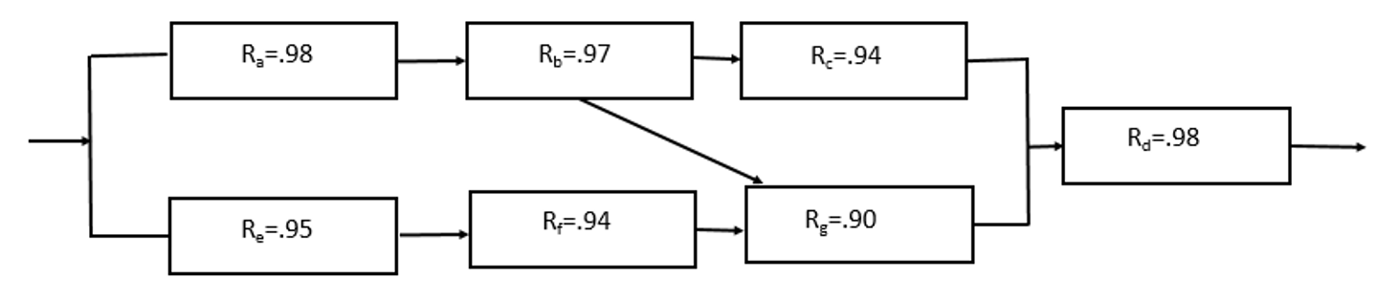

- Consider a car system which includes a so-called general function and functions a-c. For the system to be reliable, the general function and function ‘a’ need to work. However, it suffices if at least one of the functions ‘b’ or ‘c’ work. The functions themselves consist of the following components:
- General function requires the engine, steering, brakes, transmission and four wheels. Note that a spare tire is always available if an emergency situation arises. (Hint: this implies a four out of five system).
- Function a could be stated as requiring two out of three passenger seats
- Function b as requiring either a roof rack or boot
- Function c as requiring a towbar.

Draw a RBD (Reliability Block Diagram) from the information above.

