Prove that the De Broglie wavelength associated with a particle having kinetic energy K which is not negligible
compared to its rest energy 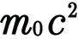 is given by

