Introduction to Decision Trees
Consider the decision from SLP2: choosing between two different alternatives. Imagine that you have a decision where there are three, four or more choices. Then consider that you may have to estimate the probabilities of two or more future states for choice. How do you model this decision in such a way so that you can visualize it easily, analyze the data, get results, and then even make changes for sensitivity analysis? The answer is to use a Decision Tree model.
Let’s take a very simple, generic problem. You have two options to choose from, A and B. let’s say two different stocks choices. You determine that there are three basic outcomes: the market goes high, the market goes medium, and the market goes low. Given the research that you have done, here are the two possible investments and outcomes for a specific period of time, say a year:
Table 1: Possible investments and outcomes
 | Option A |  |  | Option B
Market level | High | Medium | Low | High | Medium | Low
Probability | 0.4 | 0.3 | 0.3 | 0.6 | 0.25 | 0.15
Payoff | 10 | 6 | 2 | 8 | 4 | 3

You can do the calculations in Excel, like you did in SLP2. But consider that you may have more complex problems. So using a D-tree is the best way to go. Here is the way this problem looks using a D-tree in Excel using the Simple Decision Tree tool.
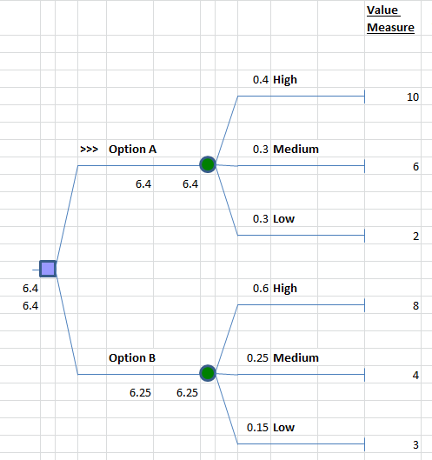
The blue square denotes a decision node. A node is a place in the tree where this branches. You see two branches from the blue decision node. These represent the two choices. The choice on the top is labeled Option A and the bottom is Option B (keeping it generic). You could label these with specific names of the stocks. Each option shows the future states. In this example, we have determined that there are two completely separate futures, indicated by the fact that the probabilities are different. But each future has three possible states: high, medium, and low, which are based on the possible behavior of the market, depending on which stock you might buy. The green circle denotes an Uncertainty node. You see the three branches coming off each of these nodes. We have labeled these High, Medium, and Low for each uncertainty node corresponding to each choice of stock. We have entered the probabilities on each branch coming off the uncertainty node. For Option A you see the probabilities 0.4, 0.3, and 0.3 and the corresponding payoffs at the end of the branches, 10, 6, and 2. For Option B you see the probabilities 0.6, 0.25, and 0.15 and the corresponding payoffs at the end of the branches, 8, 4, and 3.
Once we have created the d-tree and entered the labels, the probabilities and the payoffs, the d-tree automatically calculates the best choice. Note that on the top branch you see the Expected Value of this choice is 6.4. The bottom branch shows the Expected Value of 6.25. You also see that on the top branch, there is this symbol >>> next to Option A, which means it is the preferred choice. Then next to the blue square, you see the value of 6.4 which is the value of the best choice, Option A.
You can change the numbers and do sensitivity analysis and play “what-if” games to test out different theories and scenarios. You can add branches to any node or delete branches from any node.
Note that there are few “rules” when creating D-tree models, mostly which conform to probability theory. First, at the Choice node, you need to include all of the relevant choices, including the one, do nothing. We have done so here, but for a complete analysis, there is always the status quo or do nothing. Then each chance node must have branches that correspond to a set of mutually exclusive and collectively exhaustive outcomes. Mutually exclusive means that only one of the outcomes can happen. In our example, for either stock, the market can only do one thing, go high, medium or low. Collectively exhaustive means that no other possibilities exist and one of the specified outcomes has to occur. While not a hard and fast rule, usually time is represented from Left to Right. First the Decision Maker chooses an option, then action takes place over time and ultimately one of the future states occurs. Of course in our model we represent all possible future states.
Be sure to watch the video that shows how to create and modify a decision tree.

