Metro Dental Services

Employee Engagement Survey

Total Scores

Employee Engagement Survey

September-15

Report at a Glance
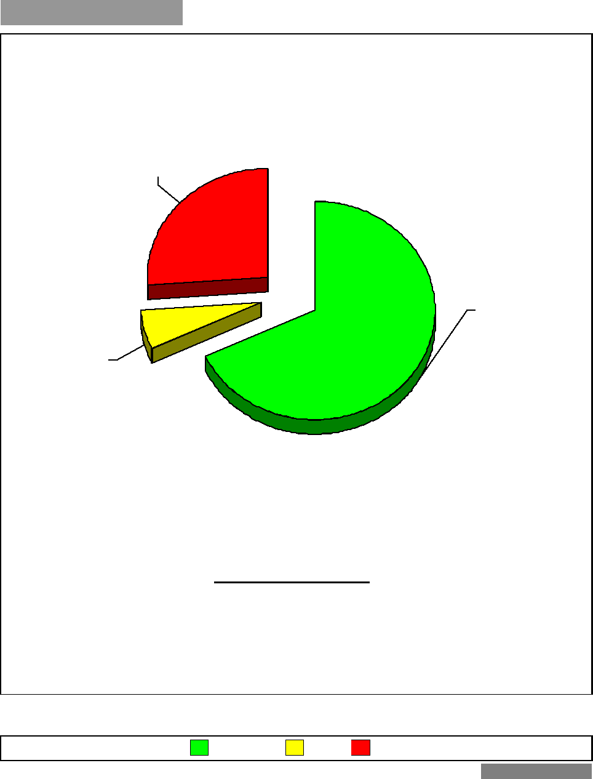
= % Unfavorable
= % N/A
= % Favorable
5.8%
68.0%
No. of Respondents: 112
26.2%

Employee Engagement Survey
Category Rank Report

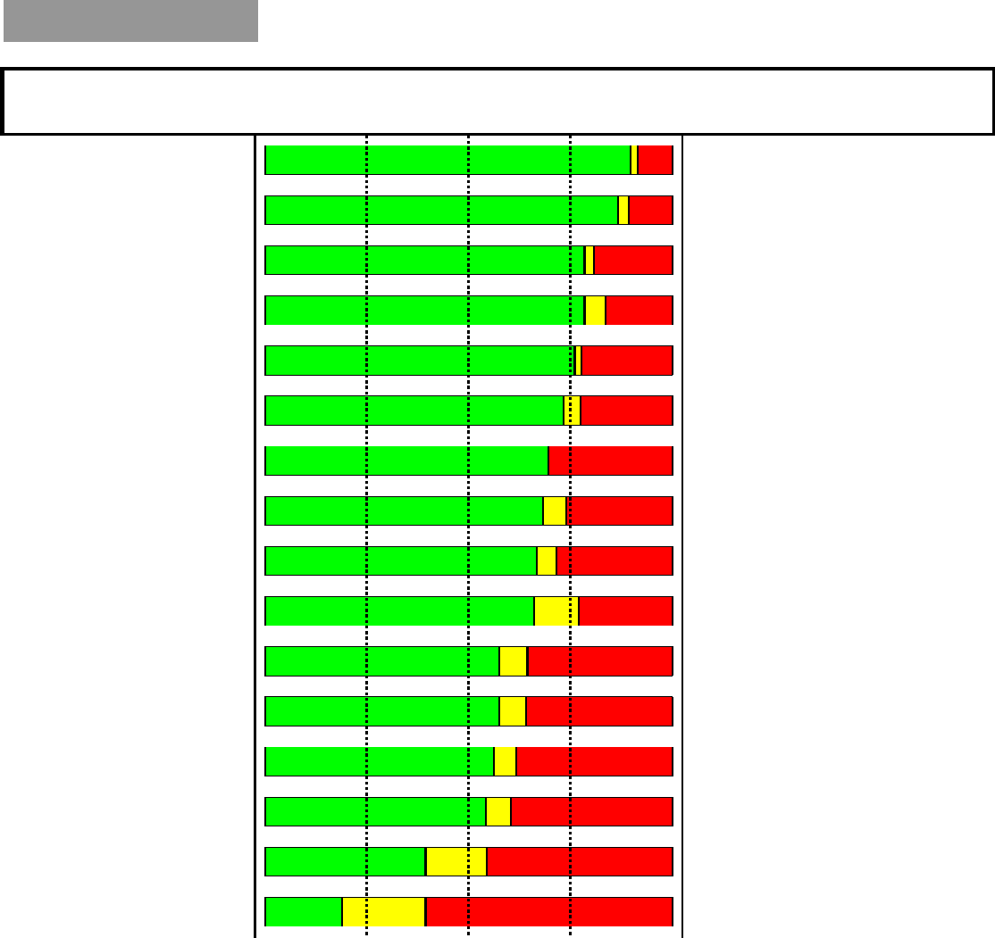
Work Demands
Identification with the
Co.
Empowerment
Teamwork
Training
Cust+Quality
Orientation
Working Conditions
Category Name
25% 50% 75%

 |  | =Favorable |  | =N/A |  | =Unfavorable

