- A Porsche GT3 Cup car’s engine has a mean time between failures of 250 hours, where the failure rate is constant. Suppose that a certain race requires failure-free operation of the engine for 20 hours. What is the probability that the engine will complete the race without failure? Please round your answer to 2 decimals.

- The hazard function of a product is given by λ = λt where λ > 0. Suppose we subject the product to the burn-in period T₀. Will the conditional reliability R (t|T₀ ) increase or decrease as the burn-in period T₀ increase?

- The failure distribution is given by the function below. What is the MTTF (in hours).
$$f\left(t\right)={\left(\frac{3t²}{10⁹}\right)}^{}, for 0 ≤t≤1000hr$$
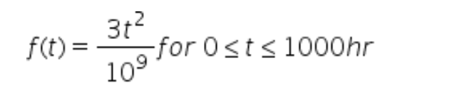
- The time to failure of a typical household refrigerator has the following pdf: What is the reliability of the refrigerator for the first year? Please round your answer to 2 decimals
$$f\left(t\right)= \left\{\begin{aligned}0.003t^{2}-0.06t+0.3 for 0≤t≤10 years \\ 0 elsewhere\end{aligned}\right.$$
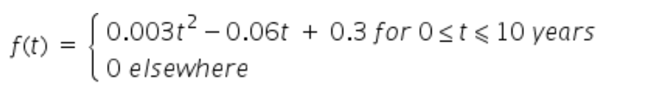

- Pick three contributing factors for observing an IFR hazard.
Hint: These factors can typically be addressed using preventative maintenance.

