- Jeru is having a debate with his classmate about whether various random variables are considered discrete or continuous. Consider the shelf life of a box of "Krispy Kreme" Donuts. Jeru states that the shelf life of a box of donuts represents a discrete event because the expiration date can only occur once. Is this true or false?

- A new fuel injection system is experiencing high failure rates. The reliability function has been found to be
where t is measured in years. Find the MTTF. Please round your answer to 2 decimals.
- What is the system reliability illustrated in the figure below? Please round your answer to 2 decimal places.

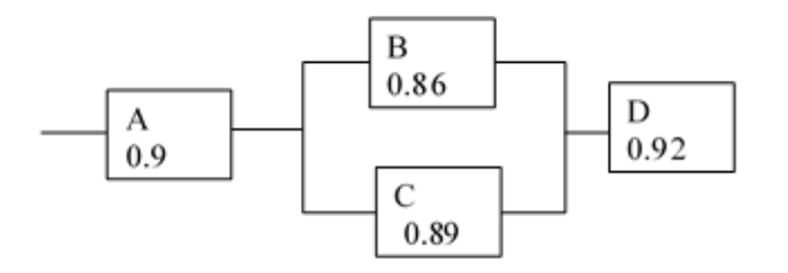

- Two cards are simultaneously drawn at random from a standard deck of 52 cards. What is the probability that both cards drawn are queens? Please round you answer to 4 decimal places.

- Suppose the condition monitoring and the failure statistics departments of company XYZ have 9 and 11 members, respectively. In how many ways can we select a committee to develop a reliability program if the committee is to consist of 3 members from the condition monitoring department and 4 members from the failure statistics department?

