Barton Publication Company, Inc., has the following comparative balance sheet as of March 31, 2010.
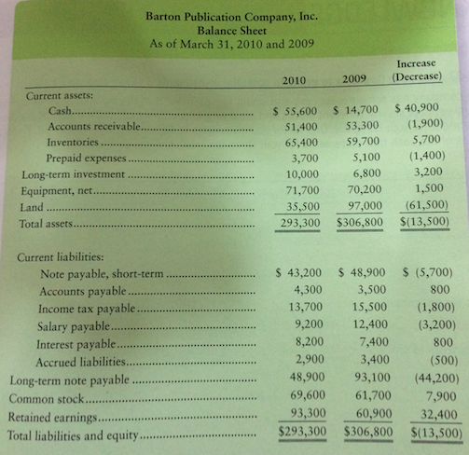
Selected transaction data for the year ended March 31, 2010, include the following:
a. Net income……………………………………………… | $77,000
b. Paid long- term note payable with cash………………… | $59,600
c. Cash payments to employees…………………………… | $43,000
d. Loss on sale of land……………………………………... | $9,600
e. Acquired equipment by issuing long- term note payable.. | $15,400
f. Cash payments to suppliers……………………………... | $147,100
g. Cash paid for interest…………………………………… | $4,100
h. Depreciation expense on equipment……………………. | $13,900
i. Paid short- term note payable by issuing common stock... | $5,700
j. Paid cash dividends……………………………………… | $44,600
k. Received cash for issuance of common stock…………... | $2,200
l. Cash received from customers…………………………... | $299,400
m. Cash paid for income taxes…………………………….. | $12,000
n. Sold land for cash……………………………………….. | $51,900
o. Interest received (in cash)………………………………. | $1,000
p. Purchased long- term investment for cash……………… | $3,200

Requirements
1. Prepare the statement of cash flows for Barton Publication Company, Inc., for the year ended March 31, 2010, using the indirect method for operating cash flows. Include a schedule of noncash investing and financing activities. All of the current accounts, except short- term notes payable, result from operating transactions.
2. Also prepare a supplementary schedule of cash flows from operations using the direct method.

