Year 11 ERT Fuels – Scaffolding
Word limit 800 -1000 words only!
Remember to in text reference your work and provide a bibliography (Correctly referenced).
Refer to the attached appendices throughout the body of the essay.
In EVERY paragraph…..THINK!
Does this relate to the statement?
How? Say that!

Remember: COST verses a result with the problem of vehicle emissions.

Introduction
- Introduce the statement and state your opinion (in 3rd person)
- What is the purpose of the task?
- What is global warming?
Body
Explain the causes of global warming (natural greenhouse effect verses enhanced greenhouse effect)
Explain the effects of global warming. Include tables and graphs.
What greenhouse gases are released through vehicle emissions? Illustrate this with a diagram, table or graph.
What percentage of greenhouse gases is produced by transport in comparison to other sectors? Illustrate this with a diagram, table or graph. Can this be converted to tonnes produced annually?
Combustion of Octane.
- Chemical equation
- Moles of octane used
- Moles of gas produced. Convert this to mass of gas produced.
Representation of the amount of gases released when 1L of petrol is burned.
How many litres of petrol, on average, are used per 100km?
How many kilometres, on average, do Australians travel per year? How much petrol is this? How much gas does this equate to?
Calculate the total mass of gases released per year by Australians through vehicle emissions.
Calculate changes in enthalpy for octane combustion. Include an energy profile.
Are there any authorities or legislation that tries to reduce vehicle emissions?
Provide a potential strategy to reduce vehicle emissions:
- Compare 2 fuels e.g. a fossil fuel and an alternative fuel source
- Compare greenhouse gas emissions from each fuel. When 1 litre of petrol is burned how much of each greenhouse gas is released. Calculate the amount of heat energy released by using bond energies (include calculations in an appendix), compare costs and energy efficiency of each fuel.
- Advantages and disadvantages; vehicle modifications, infrastructure, environmental eg oil spills, short and long term outcomes.
- Comparisons could be presented in a table
- Costs to businesses, societies and standards of living.
Possible Appendices:
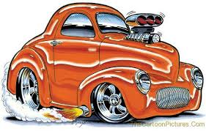
Equations
Calculations:
Moles of octane used in burning 1L of fuel
Moles of each gas produced
Mass of each gas produced
Total amount of gas produced by transport annually
Enthalpy calculations for 1L
Energy profiles

Conclusion
- Justify your opinion of the statement.
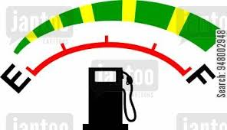
- How can global warming be addressed (specific to vehicle emissions)? How effective are these measures? Do these measures reduce or reverse damage to the environment?

