Company name: Quattro Industries, Inc.
Quattro is a privately-held company that has been manufacturing soccer balls for over a quarter of a century. Soccer balls form the company’s sole product. Quattro prides itself in manufacturing soccer balls using the latest technology with the best materials possible. In addition, the soccer balls are individually hand-stitched by trained staff to increase the balls’ strength. Quattro sells directly to the end customer directly via their website as well as through Amazon.com. The company does not utilize the services of wholesalers or distributors in their supply chain (1).
EESC of Quattro, from RAW to RETAIL
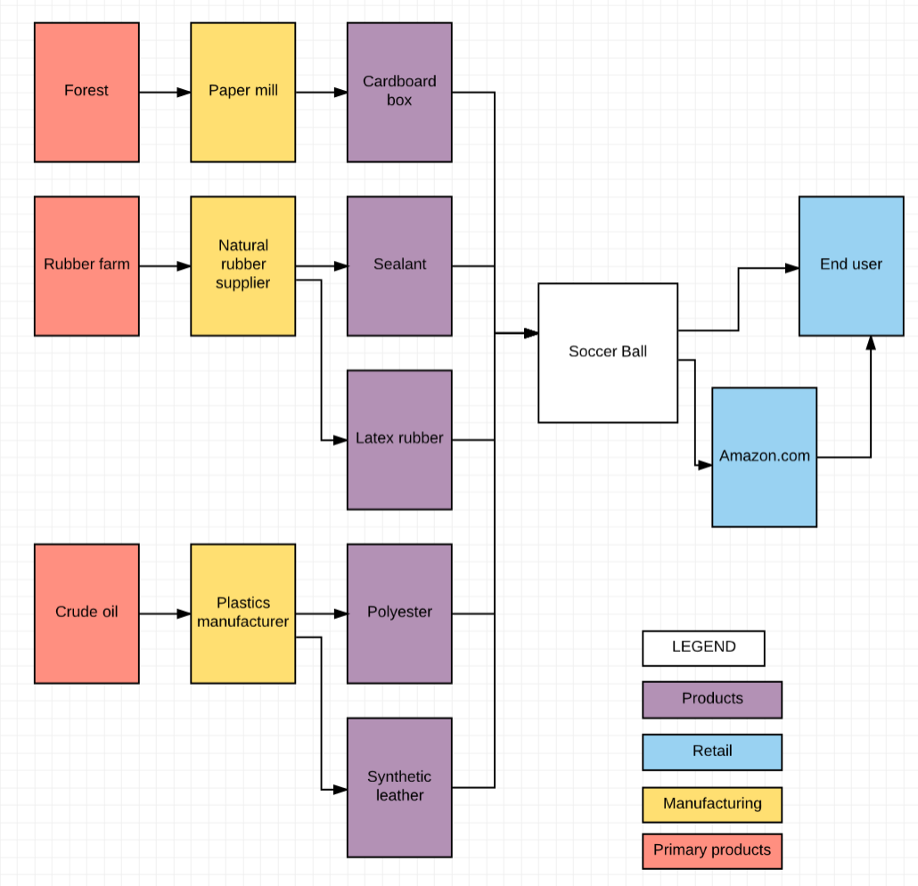

The materials needed by Quattro to produce a soccer ball are:
- Cardboard (for packaging)
- Sealant
- Latex rubber
- Polyester
- Synthetic leather (2)

In the next step upstream, the materials needed are:
- Paper or wood pulp (for manufacturing the packaging materials)
- Natural rubber
- Plastics

The raw materials needed to produce a soccer ball are:
- Wood (for manufacturing the packaging materials)
- Rubber
- Crude oil

Downstream from Quattro, the product is sold either directly to the end customer, or sold through Amazon.com. The latter is the only retailer that sells Quattro’s products.
The industries involved in the harvesting of raw materials required for making a soccer ball are: Agriculture, Forestry, and Oil/Gas extraction (3). The forestry industry is located primarily in South Carolina, Georgia and Montana in the United States. Globally, there are locations in Canada, Europe and Japan, as well as among emerging markets regions. The oil extraction industry is located among the companies that use fracking, which occurs mainly in North Dakota, Texas and California in the United States. Globally OPEC is the leading producer of crude oil. In the United States, rubber trees grow mainly on plantations located in South Carolina. Malaysia and Thailand are the main producers of rubber outside the United States (4).
An issue within the forestry industry is that environmentalists object to deforestation. The depletion of forests leads to habitat loss for the animals in the area, and this negatively affects biodiversity. In order to reduce the impact on the environment, the cardboard boxes that are used as packaging material for the soccer balls could be made out of recycled paper. In addition, the end user could recycle the boxes. An issue within the Crude oil industry is the possibility that the industry may be shut down by the government due to the industry’s contribution to global warming.
Currently, among all the raw materials, the bottleneck lies with rubber production. Since the productivity of the rubber trees decrease as the temperature rises above a certain level, global warming has taken its toll on rubber productions (5). As global warming becomes a ubiquitous issue, the price of rubber can be expected to increase in accordance. Since rubber is essential in producing both the latex rubber that forms the bladder or interior of a soccer ball as well as the sealant, the price of soccer balls can, in turn, be expected to increase. Scientists in Germany have been investigating into alternatives for rubber. It has been found that the milky sap of the dandelion plant contains raw rubber of approximately the same quality as that found in rubber trees. Although the use of dandelion rubber currently exists only on the drawing board, there are companies that intend to investigate further into the harvesting and usage of this secondary source of natural rubber (5).

References
- http://www.quattrosoccerballs.com/about-quattro
- http://www.soccerballworld.com/Soccer_Ball_Construction.htm#Stitched
- http://www.census.gov/cgi-bin/sssd/naics/naicsrch?chart=2007
- Global warming affecting rubber output, by Aravindan, June 4, 2016, Businessline. Retrieved fromhttp://www.thehindubusinessline.com/economy/agri-business/global-warming-affecting-rubber-output/article7282882.ece91
- Tire Makers Look for Alternatives to Natural Rubber, by Jim Park, April 2013, TruckingInfo.com. Retrieved from http://www.truckinginfo.com/article/story/2013/04/tire-makers-look-for-alternatives-to-natural-rubber.aspx

