1. The following information is taken from the balance sheet of Meirski Company on January 1, 2009:
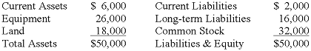
Use the information on January 1, 2009 to determine the effect of the following entry on the current ratio of Meirski Company:
This transaction will:
have no effect on the current ratio.
cause the current ratio to decrease.
cause the current ratio to increase.
potentially affect the current ratio, but the direction of the change cannot be determined without more information.

2. Zipper Company understated its ending inventory. Which of the following answers correctly states the effect of the error in the present period?
Overstatement of total assets and cost of goods sold.
Understatement of total assets and gross margin.
Understatement of liabilities and retained earnings.
Overstatement of cost of goods sold and retained earnings.

3. The owner of the Kacie Company established a petty cash fund amounting to $425. What is the effect on the financial statements of the entry to record this transaction?
4. Flint Enterprises started the period with 150 units in beginning inventory that cost $2 each. During the period, the company purchased inventory items as follows:
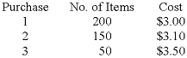
Flint sold 200 units after purchase 3.
Flint's ending inventory under LIFO would be:
$1,240.
$1,090.
$900.
$980.

5. Ganz Company established a $350 petty cash fund on January 1, 2009. On March 1, 2009 the fund contained $260 in receipts for miscellaneous expenses and $88 in cash. The entries necessary to replenish the petty cash fund will:
increase assets by $350.
decrease equity by $348.
increase equity by $262.
decrease assets by $262.

6. Vulcan Co. uses the perpetual inventory method. The inventory records for Vulcan reflected the following:
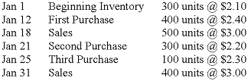
Assuming Vulcan uses a FIFO cost flow method, the cost of goods sold for the sales transaction on January 31 is:
$860.
$920.
$880.
$840.

7. Michaels Company uses the perpetual inventory method. Michaels purchased 500 units of inventory that cost $4.00 each. At a later date the company purchased an additional 600 units of inventory that cost $4.50 each. If Michaels uses a LIFO cost flow method, and sells 800 units of inventory, the amount of ending inventory appearing on the balance sheet will be:
$1,400.
$1,350.
$1,200.
$1,450.

8. Barney Company purchased two identical inventory items. The item purchased first cost $7.00, and the item purchased second cost $9.00. Barney sold one of the items for $12.00. Which of the following statements is true?
Ending inventory will be lower if Barney uses weighted average than if FIFO were used.
Cost of goods sold will be higher if Barney uses FIFO than if weighted average were used.
The dollar amount assigned to ending inventory will be the same no matter which cost flow method is used.
Gross margin will be higher if Barney uses LIFO than it would be if FIFO were used.

9. The inventory records for Rain Co. reflected the following:
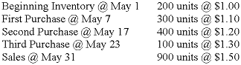
Determine the amount of cost of goods sold assuming the LIFO cost flow method.
$1,140
$1,040
$1,000
$940

10. When prices are rising, which method of inventory, if any, will result in the lowest relative net cash outflow (including the effects of taxes, if any)?
weighted average.
FIFO.
LIFO.
None of these; inventory methods cannot affect cash flows.

11. Zabel Company's petty cash fund was established on January 1, 2009 with $500. On January 31, 2009 a count of the fund revealed: $103 in cash remaining and vouchers for miscellaneous payments totaling $400. What effect will the necessary entries to replenish the fund have on the company's financial statements?

12. Wesley Corporation's 2007 ending inventory was overstated by $20,000; however, ending inventory for 2008 was correct. Which of the following statements is correct?
Net income for 2007 is understated.
Retained earnings at the end of 2008 is overstated.
Cost of goods sold for 2008 is overstated.
Cost of goods sold for 2007 is overstated.

