Employee Satisfaction Model

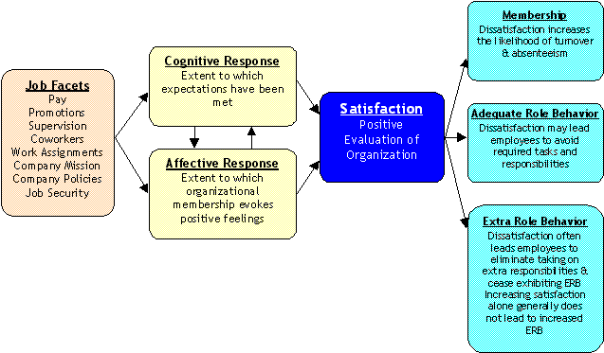

Determinants of Job Satisfaction
Job satisfaction or Employee Satisfaction (also referred to as morale) is one of the most used variables in Organizational Behavior. It is an employee's attitudinal response to his or her organization. As an attitude, job satisfaction is summarized in evaluative component and comprised of cognitive, affective, behavioral components. As with all attitudes, the relationship between satisfaction and behavior, most specifically job performance and membership, is complex. The table below summarizes the cognitive and affective components of job satisfaction; their relationship to organizational inducements systems and their impact on performance and membership.
The Evaluative Component- An individual's overall response to the employing organization is summarized in the evaluative component. It represents dislike vs. like for the organization.
The Cognitive Component- An individual's perceptions, opinion, beliefs and expectations regarding the organization are the focus of his or her cognitions. Employees hold cognitions about each of the four major inducement systems. Cognitions in which the individual perceives that his or her expectations have been met generally lead to positive evaluations. Additionally, positive evaluations are more likely when cognitions (expectations) support a positive and secure future with the organization. Some of the specific cognitions regarding each inducement systems are:
Reward Inducement System- Individuals develop expectations regarding their their pay through negotiations, comparison to others, and promises made. Satisfaction is increased when these salary expectations are met. Likewise individuals develop an expected timetable for advancement. The extent to which these timetables are met also influences the individuals' cognitive evaluation. (see Equity Theory)
Managerial Inducement System- Satisfaction with one's boss is a function of how he or she meets your mental model (expectations) of how a leader should behave.
Task Inducement System- The extent to which one's assigned task and responsibilities meet role expectations is the major determinant of an individual's cognitive assessment of his or her job.
Social Inducement System- How coworker behave relative to your expectations of them and how they help or hinder your job performance is the basis of the cognitive appraisal of this inducement system.
The Affective Component- The represents the feeling evoked by the organization. Does thinking about and association with the organization evoke pleasurable or uncomfortable feelings; feelings of anger or joy; feelings of security or stress; feelings of affirmation or invalidation? In general, positive affect results from information, feedback, and situations that affirms or reinforces the individual's self worth and self concept, while negative affect is evoked by invalidating situations. Self worth is validated when individuals feel accepted as values members of the organization and their competencies and core values are affirmed. When individuals are in a positive affect state while working, they tend to evaluate the organization positively. Some of the ways in which the individual's affective component is triggered by each of the inducement systems are:
Reward Inducement System- Pay has a pure instrumental meaning, that is, it is valued as means of purchasing necessary and desirable goods and services. Pay also has an expressive meaning in that it used by many as a major indicator of worth and status. The reward system impacts on an individuals emotional attachment to the organization by the degree to which one's pay and organizational position validates his or her self worth and status.
Managerial Inducement System- One of the major sources of validation is social feedback. Positive affect is created when others affirm one's worth, competencies, values, and status. The extent to which one's boss indicates that you are a valued and skilled employee through his or her words or actions affects your emotional (affective) response to him or her.
Task Inducement System- Another source of validating feedback comes from direct task feedback. When individuals can affirm their competencies and values through their jobs, positive affect is created. Emotional satisfying jobs either are intrinsically pleasures or create the conditions whereby the individuals feels that they are making a contribution to something of value and that they have an impact on the success or failure of goals and projects.
Social Inducement System- The extent to which employee enjoys social interactions at work and degree to which work social interactions are affirming of one's identity (acceptance, worth, and status) leads to satisfaction with coworkers. For high satisfaction to occur, peer (social) feedback and acceptance is generally unconditional and positive.
Consequences of Job Satisfaction and Dissatisfaction
The relationship between job satisfaction and employee behavior is complex. Job satisfaction combines with employee motivation to influence certain behavioral patterns.
Membership- The strongest tie between job satisfaction and behavior is found in the employee membership decision. In the evaluation is negative, employees tend to look elsewhere for employment when alternatives are available. When expectations of future security advancement or low (cognitive evaluation), the organization does not compare favorably to alternative employment sources. When individuals experience strong negative affect and are consistently in a negative affect the state, they avoid coming to work (absenteeism) and look for ways to relieve themselves of this negative affective state by looking for other means of employment (negative reinforcement). Therefore, we find a relatively strong relationship between satisfaction and long-term membership and dissatisfaction and turnover and absenteeism.
Adequate Role Behavior-A As long as individuals remain satisfied in which to continue employment, they tend to do what is necessary to stay employed, that is, meet at least the minimum role expectations. Additionally, they engage in behaviors that maintain satisfying relationships with supervisors, subordinates, and co-workers. As individuals become dissatisfied with their work, they tend to look for ways to reduce minimum requirements. In some cases, extreme dissatisfaction (especially dissatisfaction that has a strong affective component) can lead to behaviors destructive to the organization. Highly dissatisfied employees can sabotage programs and services in an attempt to "get back" at the organization for its managers.
Extra Role Behavior- For extra role behavior to occur, there must be some source of motivation (contingent relationship between extra role behavior and either pay, positive social feedback, positive task feedback, or goal accomplishment). While high levels of satisfaction reinforces existing extra role behavior motivated by the inducement systems, satisfaction alone does not generate high levels of extra role behavior. However, dissatisfaction can have a strong suppressor effect on extra role behavior. That is, extra role behavior that is motivated by one inducement systems can be reduced when individuals become dissatisfied. Dissatisfied workers are unlikely to take on new responsibilities, go out of their way to help fellow employees, or go beyond job requirements in an effort to help customers are clients. This is especially true when the source of dissatisfaction is with supervisors or peers. Increasing satisfaction (by removing sources of dissatisfaction) is likely to increase membership, but will not generate extra role behavior unless some source of motivation is present.

