Notes on the Job Characteristics Model
Prepared by Debra J. Louis, PhD
Trident University International
This model provides insight into how one can design jobs so that the job itself is motivating. In order to do this, the manager must first understand the core characteristics of jobs. They are depicted in the slide below and defined in the text below the slide. The developers of this model, Hackman & Oldman, recommend analyzing a job based on the degree to which it possesses these core characteristics and then improving the design on a characteristic-by-characteristic basis. Enriching skill variety, task identity, and task significance while providing autonomy and knowledge of the results of the work boosts three critical psychological states (meaningfulness, responsibility, and knowledge of results) which then produce improved work outcomes, including satisfaction and motivation.
However, the manager must take into account the personality differences between employees. People with a high need for growth, learning, and accomplishment tend to respond favorably to jobs that have been enriched by using this model, but this is not necessarily true for people with low growth needs.
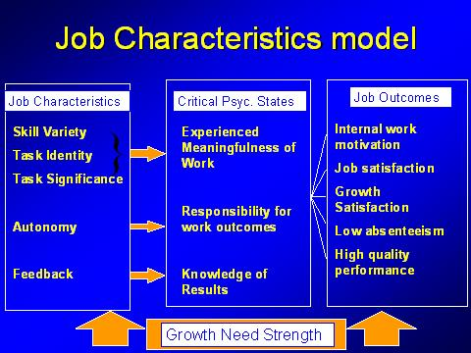
Job Characteristics
Skill variety: The ability to use several different skills in one's job
Task Identity: The degree to which a job involves the completion of an entire piece of work - from start to finish
Task significance: job has a perceivable impact on the lives of other people
Autonomy: job holder has freedom, independence and discretion in scheduling work and deciding how the work will be done
Feedback: in carrying out the job, the person gets information about his/her effectiveness
Experienced Psychological States (these are affected by core job dimensions):
Experienced meaningfulness of work is affected by skill variety, task identity, task significance.
Experienced responsibility for work outcomes is affected by task autonomy.
Knowledge of results is affected by feedback.
Work Outcomes (these are affected by experienced psychological states):
High work motivation
High satisfaction
Low turnover
Low absenteeism
Growth need strength
A personality characteristic that refers to the degree to which a person wants to have opportunities for self-direction, learning, and personal accomplishment.

