Include the following details and descriptions in your report from the graph given.

- Subject (or subjects).
- Setting.
- Baseline.
- Treatments.
- Appropriate dependent behavior to be targeted for habit breaking.
- Self-monitoring procedure.
- Awareness training.
- Implementation of self-monitoring and awareness training.
- Target behavior.
- Design.
- Results.
- Conclusions.
- Strengths or limitations of the multiple-baseline.
- Strengths or limitations of treatment (independent variables).

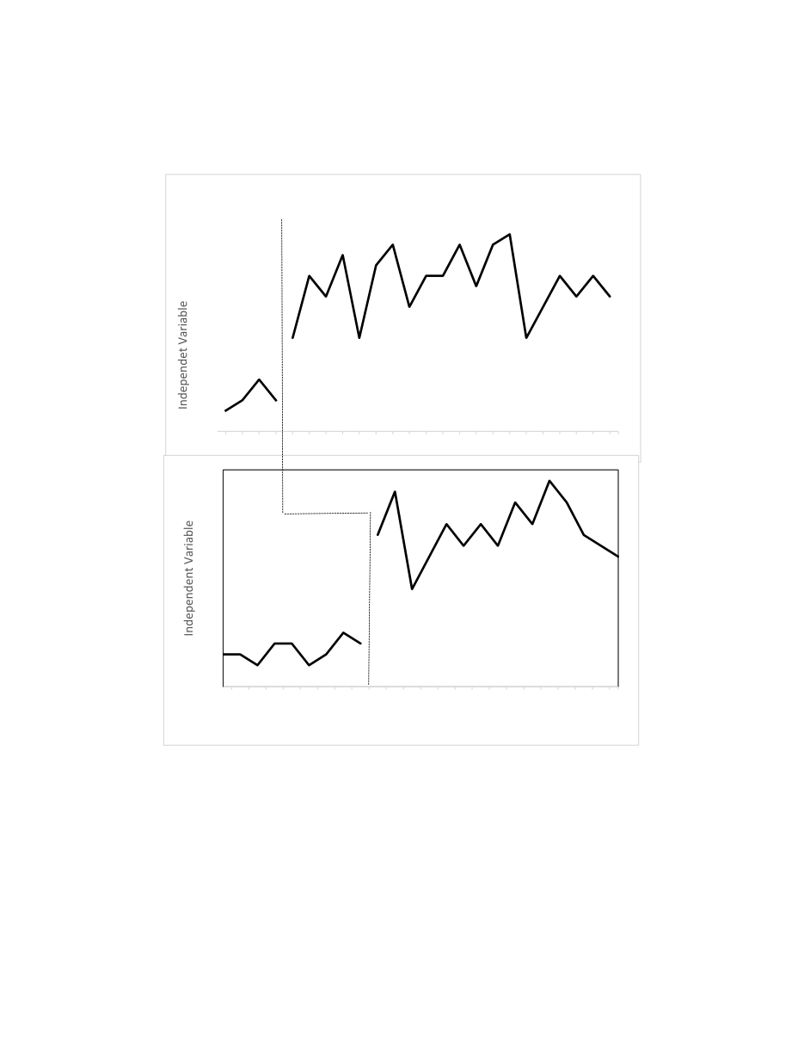
Sessions
Kate
Sara
Intervention
Baseline
Nose Picking

