Prove that the polynomial
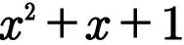 is irreducible over F, the field of integers modulo 2.

