- Determine if the following series are convergent or divergent
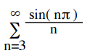
- Find the values of x for which
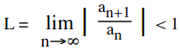
and tell if the series converges or diverges when given the series

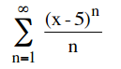

- Find power series for the following functions
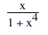
- Write down the first 4 Taylor polynomials around zero and plot f(x) a long with its approximation
$$f\left(x\right)=e^{2x+1}$$

- Use the integral test to determine if the series converges or diverges
$\sum_{k=1}^{∞}{\frac{1}{2k}-}\frac{1}{2k+1}$
- Use the comparison test test to determine if the series converges or diverges

$\sum_{k=1}^{∞}{\frac{1}{2k^{4}+8}}$

- EVALUATE THE INTEGRALS. USE TRIG SUBSTITUTION AND SHOW WORK
