5. | Perform the requested operation or operations.  f(x) = 2x - 9, g(x) = 4x - 4  Find (f - g)(x)
 | Answer. -2x - 5

6. | Compare the graph of the given quadratic function f with the graph of y = x²  f(x) = (x - 8)² + 4
Answer. | a translation 8 units right and 4 units up

Solve the problem
Find (f ° g)(3) when f(x) = -5x + 2 and g(x) = 8x² + 9x + 7
Answer: -528

8. | Compute and simplify the difference quotient  f(x + h) - f(x)  H  , h ≠ 0.

Answer: 4
10. | Consider the function h as defined. Find functions f and g so that (f ° g)(x) = h(x).  h(x) = $\frac{10}{x^{2}}+4$  answer. f(x) = x + 4, g(x) = $\frac{10}{x^{2}}$

11. | Solve the problem.  Find (f °g)(-6) when f(x) = 4x + 4 and g(x) = 6x2 - 3x - 6.
Answer: 916

13. | Determine whether or not the function is one-to-one.  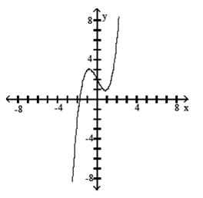
15. | Perform the requested operation or operations.  f(x) = 9x - 4, g(x) = 6x - 6  Find (f - g)(x).
Answer: 3x + 2
16. | Graph the basic function using a solid line and the transformed function using a dotted line.  y = -3 |x|  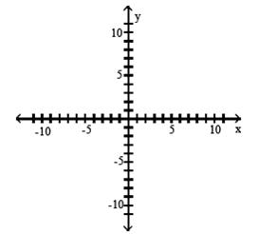  20. Solve the problem Select the equation that describes the graph shown  A. y = (x + 2)²- 4  B. y = (x + 4)² + 2  C. y = (x - 4)² + 2  D. y = x² - 4

