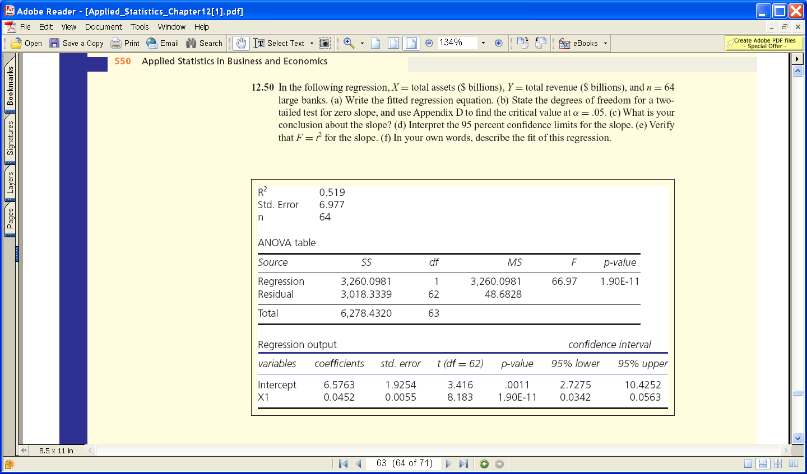

Appendix D is located below. It is broken into two parts.
The first one shows columns 1 thru 12. The second one shows columns 13 thru 35.
