- Let B(x) represent the area bounded by the graph and the horizontal axis and vertical lines at t=0 and t=x for the graph shown below. Evaluate B(x) for x = 1 and 5.
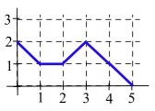

- For $f\left(x\right)=\frac{1}{x+1}$ find

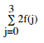

- Find the areas of the rectangles:

- Rewrite as a definite integral. Do not evaluate.

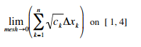

- Represent the area bounded by the regions as a definite integral and evaluate.

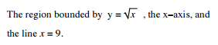

- Your velocity along a straight line is shown below
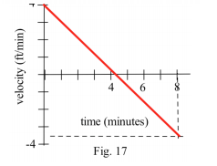

- Use Leibniz rule to find:
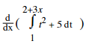

- Use change of variables to find:
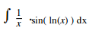
- Sketch the graph of the two functions and find the area between them.
